4 Rivers for LIFE

Screening for riparian tree planting
SITE INFORMATION
Landowner Name |  | Telephone Number |  | Email Address
Jim Thomas |  | 01558 668350 |  | Deidyff@hotmail.com
Farm Name and Address |  |  |  | Site Visit Date | Planting Season
Dyffryn Isaf
Llanfynydd
Carmarthen
SA32 7TT
 |  |  |  | Site Officer
Grid Reference | SN537260
TYPE AND SCALE OF PROPOSED PLANTING (low density riparian)
Approximate area for planting
Current land use (photograph) | 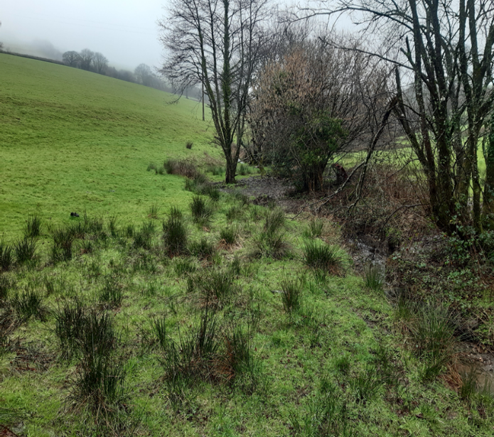
Upland or lowland

Map of site (including proposed planting area, existing features such as hedgerows and rivers, existing or proposed fencing).
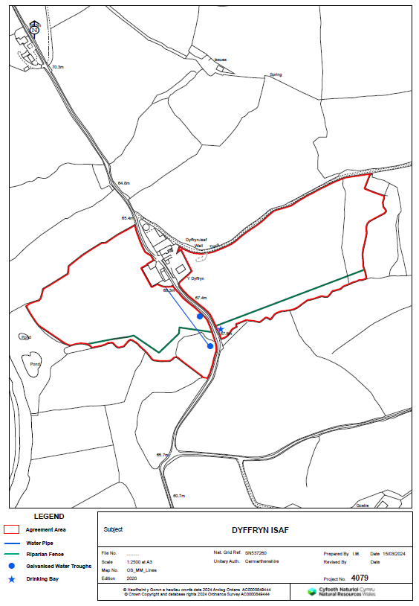

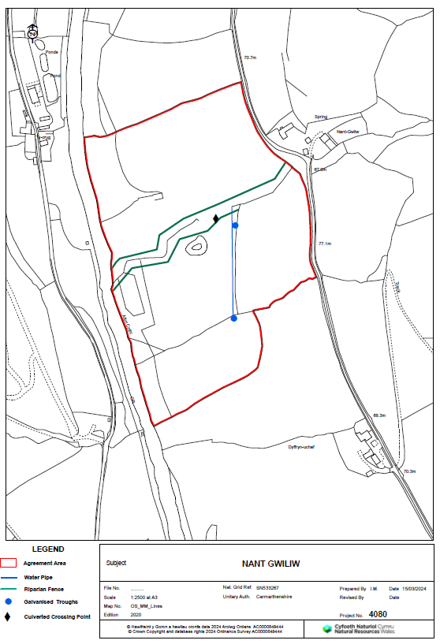

PLANTING PLAN
Area planted (m²) | Species and number | Total density | Tree guards used? | Type of tree guards | Undertaken by: | Notes

DESK BASED CONSTRAINTS
Type | Y/N | Consultation Required? | Description | Conclusion
National Park ** | N
SSSI * and buffer (Biological 300m buffer, river 100m buffer) | N
SAC Special Area Conservation (300m buffer) | N
AONB * | N
Special Protection Area * (SPA) (500m buffer) | N
RAMSAR Site * | N
National Nature Reserve * | N
Local Nature Reserve * | N
Regionally Important Geodiversity Site (RIGS) | N
Site Important for Nature Conservation (SINC) | N
World Heritage Site * | N
Scheduled Monument * (Buffer 50m) | N
Archaeological Features  (Historic Environment Features (HEF) or Historic Landscape Area (HLA)) | N
Common Land | N
Open Access Land (CRoW Act 2000) | N
Public Rights of Way (PRoW) | N
Deep Peat | N
Type | Y/N | Consultation Required? | Description | Conclusion
Priority Habitat | N
Acid sensitive waterbodies | Y
Sensitive arable plants | N
Hedgerows and veteran trees
Ancient Semi Natural Woodland (ASNW) or Existing Woodland / National Forest Inventory (NFI) | N
Prime agricultural land
Sensitive mammal species  (Water vole, dormouse (NBN Atlas), red squirrel, otter) | N
Potential habitat for open ground dependent birds  (e.g., Chough, Curlew, Lapwing, Golden Plover) | N
Records of sand martins | N
Potential habitat for grassland fungi | N
Bracken with pearl bordered fritillary habitat | N
Potential habitat for Great Crested Newt | N
Flood defence structure (buffer 8m) | N
Underground or overhead services
Private water supply

Interactive Map Viewer (cyfoethnaturiolcymru.gov.uk) green
Glastir Woodland Creation 2022 (cyfoethnaturiolcymru.gov.uk) red
Geospatial Map Viewer (cyfoethnaturiolcymru.gov.uk) blue

