Ymddiriedolaeth Archaeolegol  Dyfed  Neuadd y Sir  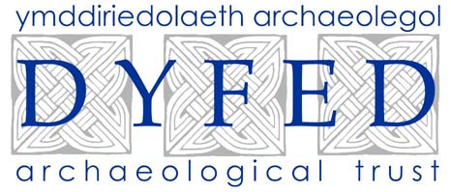  Stryd Caerfyrddin  Llandeilo  Sir Gaerfyrddin  SA19 6AF  Ffon 01558 823131  Ffacs 01558 823133  Ebost: info@dyfedarchaeology.org.uk |  | Dyfed Archaeological Trust  The Shire Hall  Carmarthen Street  Llandeilo  Carmarthenshire  SA19 6AF  Telephone 01558 823131  Fax 01558 823133  Email:info@dyfedarchaeology.org.uk

BETTER WOODLANDS FOR WALES MANAGEMENT PLAN
HERITAGE MANAGEMENT INFORMATION
(WHE1)

Prepared for: Stradmore
BWW Reference No 16900
Prepared by Will Steele
Project Record No. 93854

INTRODUCTION AND OBJECTIVES

Historic Landscape Character & Archaeological and Historical Content
The consultation comprises several separate woodland parcels lying between the communities of Beulah, Ceredigion and Manordeifi in Pembrokeshire. This landscape incorporates the middle reaches of the Teifi valley which is notable for having a number of small estate landscapes and has a strong element of design in some areas.
Part of the consultation area falls within the Lower Teifi Valley Historic Landscape Character Area HLW (D) 14. Each landscape is divided into 'character areas', which are intended to define places where local land-use patterns have left particularly strong or distinctive evidence in the landscape. The application areas lie within the Historic Landscape Character Areas 399: Plas-y-berllan and 400: Llandygwydd.
The larger of the two woodlands incorporates part of Stradmore Wood and Gwachal Dwmlo which fringe the drive running north-east of Stradmore mansion, whilst the smaller parcel incorporates part of a long shelter belt lying to the north-east of Pentre Mansion. All woodlands show an combination of both deciduous and coniferous trees in their make up, suggesting that exotic parkland species may historically have been important in their make up.

Historic Environment Objectives
The purpose of the management is to
- Ensure the survival of visible historic features.
- Ensure archaeological deposits beneath the ground surface are not disturbed.
- Prevent progressive degradation of historic environment features by promoting sympathetic woodland management.
- Ensure the long-term preservation of features associated with historic woodland.
- Maintain or restore the historic configuration and visual character of the historic landscape.

GENERAL MANAGEMENT REQUIREMENTS
All historic earthworks, structures, archaeological sites and traditional buildings must be retained and protected against damage. The following list identifies those Historic Environment Features affected by this application and the accompanying mapping shows each of these and identifies a sensitive area surrounding it. These sensitive areas must be actively managed for the life of the woodland management plan in accordance with the following requirements, in line with the Forestry Commission's Forestry & Archaeology Guidelines, 1995.
Planning
- Ensure that new planting and re-planting schemes are planned to avoid the sensitive areas surrounding historic environment features. Ideally these sensitive areas should not simply be left as unplanted islands in otherwise continuous woodland. Wherever possible these sensitive areas should be incorporated into larger buffer zones or clearings to facilitate access and ongoing management. Specific planting schemes involving historic environment features should be discussed with the Dyfed Archaeological Trust at the planning stage.
- In areas of grazed woodland, grazing regimes and stocking levels should be approved by the Dyfed Archaeological Trust prior to implementation. Similar approval should also be sought prior to significant changes to agricultural regimes.
- Consideration should be given to lessening the visual impact of new planting on historic environment features and historic landscapes.
- Consideration should be given to allowing / maintaining public access to historic environment features in woodland where this is both safe and practical. Specific access and interpretation schemes involving historic environment features should be discussed with the Dyfed Archaeological Trust at the planning stage.
- Ensure contractors and all other workers are aware of the historic environment features and comply with these requirements. They should take appropriate measures to avoid accidental damage.
Mitigation
- Do not plant or re-plant trees within the defined sensitive areas surrounding historic environment features without the prior approval of the Dyfed Archaeological Trust.
- Do not carry out any excavation or erect any new building or structure in the vicinity of historic environment features without the prior approval of the Dyfed Archaeological Trust.
- Do not site new fencing or vehicular tracks within the sensitive areas of historic environment features without the prior approval of the Dyfed Archaeological Trust.
- Do not remove any material from the sensitive areas of historic environment features or deposit spoil or rubbish on them.
- Do not store timber or machinery within the sensitive areas of historic environment features.
- Do not use heavy machinery in the sensitive areas of historic environment features, especially in wet weather.
- Do not harvest or otherwise fell trees within the sensitive areas of historic environment features without prior discussion with the Dyfed Archaeological Trust.
- No intrusive archaeological investigation (such as excavation, field-walking to collect surface finds or metal detecting) should be allowed without the prior approval of the Dyfed Archaeological Trust, to ensure that such work complies with appropriate guidance - the Institute of Field Archaeologists Code of Conduct and Standards and Guidance, and the Code of Practice for Responsible Metal Detecting in England and Wales, 2006.
Proactive management
- Control scrub and naturally regenerating trees within the sensitive areas of historic environment features. Such vegetation should be cut off at ground level with its roots being left in the ground rather than pulled up or dug out. Ensure that machinery does not cause further disturbance.
- Remove any dead or unstable trees from the vicinity of historic environment features, leaving roots to rot in situ. Ensure that machinery does not cause further disturbance.
- Where appropriate, undertake regular brashing of trees within the sensitive areas of historic environment features.
- Remove brash or other dead vegetation from the sensitive areas of historic environment features with care. Ensure that machinery does not cause further disturbance.
- Wherever practicable, repair and reuse original historic environment features, such as boundary walls, rather than replace them. Repairs should be unobtrusive and where possible make use of appropriate traditional materials and methods of construction. Schemes of repair should be discussed with the Dyfed Archaeological Trust prior to implementation.
Legislation and Guidance
- Scheduled Ancient Monuments (SAMs) have statutory protection and consent from Cadw will be required for works to these monuments.
- Listed buildings have statutory protection and permission from the Local Planning Authority will be required for some works. Listed status may also apply to buildings and structures within the curtilage of a listed building.
- Areas of historic parkland of national importance are included on the Cadw/ICOMOS Register of Parks and Gardens of Special Historic Interest in Wales. There are also many non-registered parks of lesser quality but which, nevertheless, form an important component in the historic environment and require appropriate management.
- A number of historic landscapes are registered in the Cadw/ICOMOS/CCW Registers of Outstanding and Special Landscapes of Historic Interest in Wales.
- The reporting of archaeological finds arrising from woodland work must comply with the Treasure Act, 1996. Guidance on this and on the reporting of other portable antiquities can be found on the Portable Antiquities Scheme website (http://www.finds.org.uk).
Scheduled and listed sites and registered areas are identified as such below.

HISTORIC ENVIRONMENT FEATURES
A search of the regional Historic Environment Record (HER) held by the Dyfed Archaeological Trust has identified the following historic environment features. These are listed and described below and are shown on the accompanying map. Each feature is allocated a unique reference number (a Primary Record Number - PRN) that should be quoted in any correspondence.
Each site listed must be managed in accordance with the General Management Requirements outlined above. Where sites require specific management this is set out below. These Specific Management Requirements are in addition to and (in the case of conflict) take precedence over the General Management Requirements.
PRN 15479 |  | Post-Medieval quarry | SN25504235

A quarry is recorded here on the Ordnance Survey 1st edition map (1888).
PRN 93855 | UNKNOWN | Post-Medieval cottage? | SN25834292
The tithe map records a small building in the south of a field enclosure, presumably identifying a cottage site. No further clues are provided on the apportionment. The building is marked in outline by the time of the Ordnance Survey 1st edition map (1888), presumably having been abandoned by that time.
PRN 93856 |  | Post-Medieval quarry | SN25694267
The Ordnance Survey 1st edition map (1888) identifies an "old quarry" at this location suggesting that it had become disused by that time.

Sources consulted:
Historic Environment Record for Carmarthenshire, Ceredigion and Pembrokeshire
Ordnance Survey 1st edition 1889 Cardiganshire Sheet 38.12, 25"
Ordnance Survey 1st edition 1888 Cardiganshire Sheet 38.16, 25"
Ordnance Survey 1st edition 1890 Cardiganshire Sheet 38.15, 25"
Ordnance Survey 1st edition 1888 Cardiganshire Sheet 38.16, 25"
Tithe Map & Apportionment 1841? Llandygwydd Ph.
Other sites may be known to the landowner and these should be made known to the Dyfed Archaeological Trust in order to update the Regional Historic Environment Record and where necessary amend management advice.

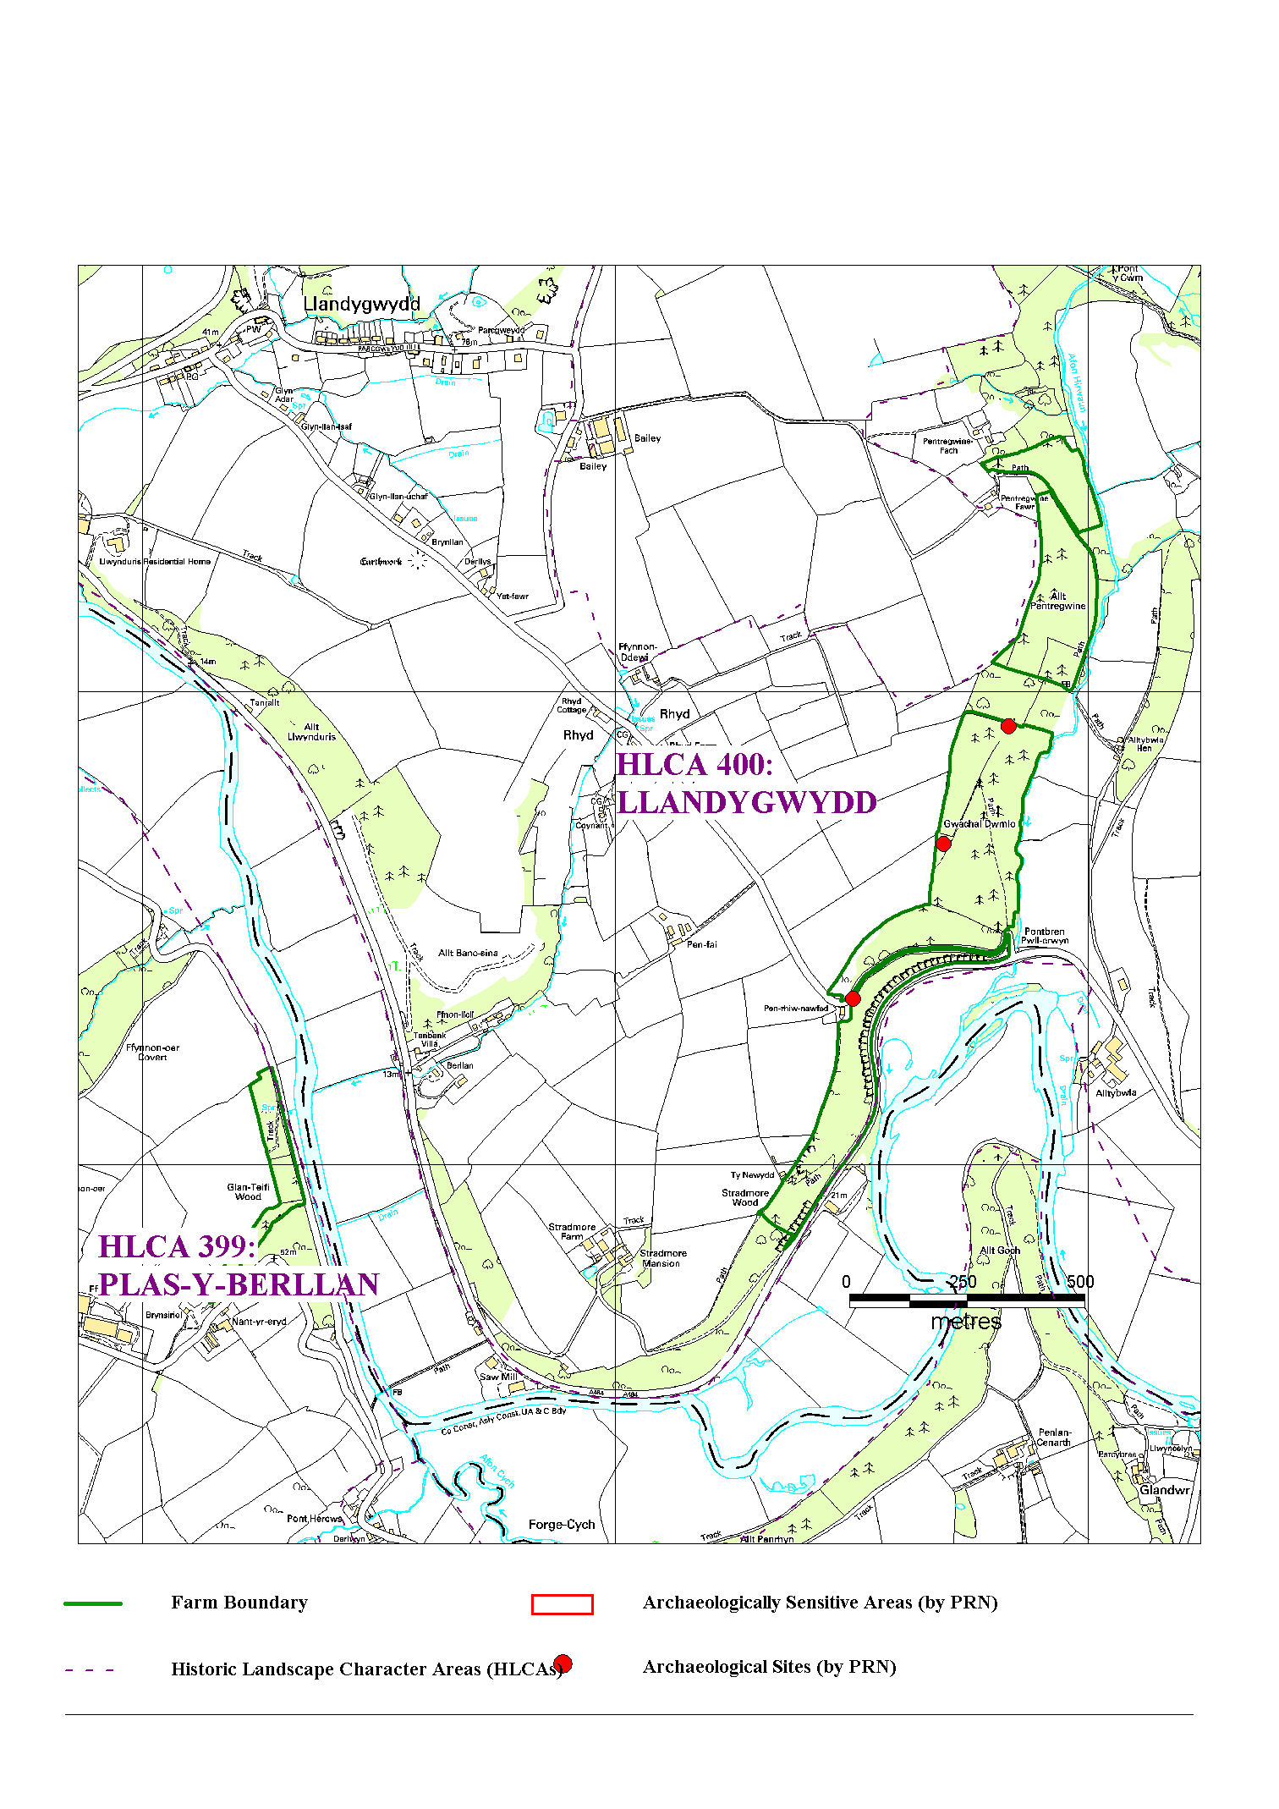

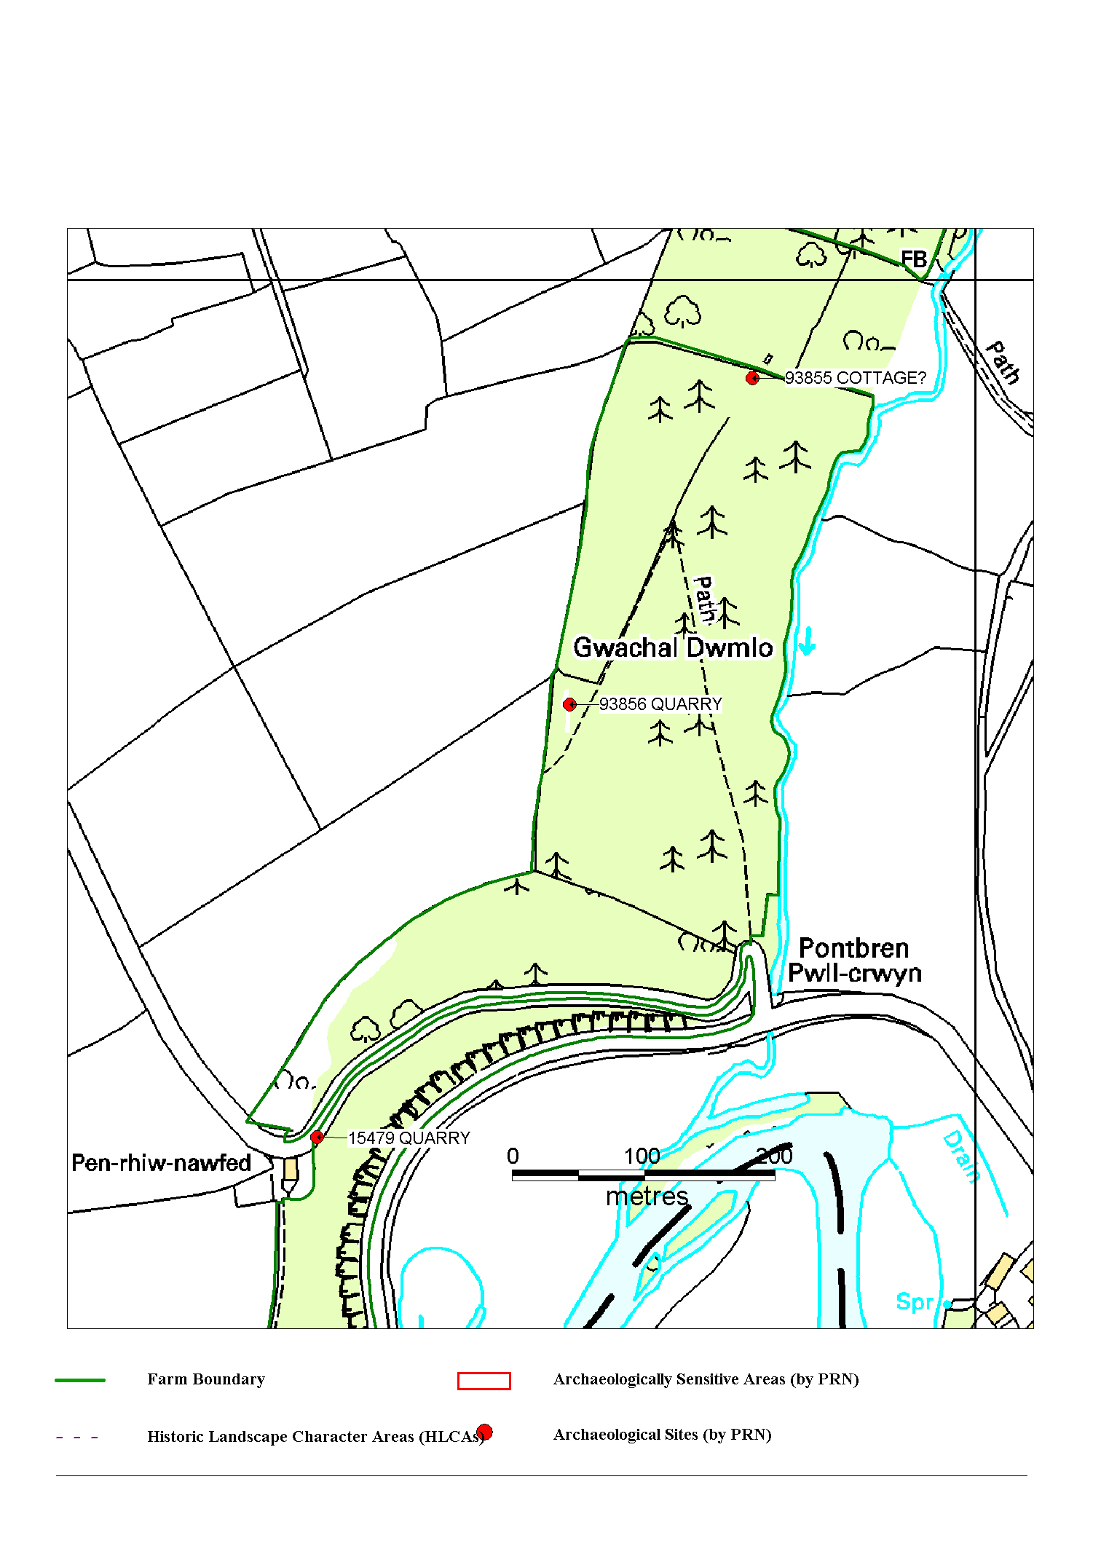

Based upon the Ordnance Survey map with permission of the Controller of HMSO. © Crown Copyright Reserved.
Ordnance Survey license number GD272388. 29/08/2008 14:17

WS - 29/08/2008 ( 14:11:23 ) - HTML file produced for Better Woodlands for Wales WHE1 report, Dyfed Archaeological Trust Project record number 93854.
Dyfed Archaeological Trust, The Shire Hall, Carmarthen Street, Llandeilo, Carmarthenshire, SA19 6AF.
tel (01558) 823131, fax (01558) 823133, email info@dyfedarchaeology.org.uk, website www.dyfedarchaeology.org.uk

APPENDIX:
Historic Landscape Character Area description 399: Plas-y-berllan; 400: Llandygwydd
LOWER TEIFI VALLEY

HISTORIC LANDSCAPE CHARACTER AREA:
399 PLAS-Y-BERLLAN

GRID REFERENCE: SN217416
AREA IN HECTARES: 473

Historic Background
This is a medium-sized historic landscape character area within modern Pembrokeshire, represented by agricultural land comprising medium-sized, fairly regular pasture fields, with some arable and scattered woodland, on the scenic southern slopes of the Teifi valley.

This area lies within the medieval Cantref Emlyn, in Emlyn Is-Cych commote. Cantref Emlyn had been partly brought under Anglo-Norman control in c.1100 when Emlyn Is-Cych commote was reconstituted as the Lordship of Cilgerran. Cilgerran remained a marcher lordship, administered from Cilgerran Castle, which was established in c.1100. The lordship was regained by the Welsh in 1164 and remained under their rule until 1223. From 1339 it was held of the Earldom of Pembroke, which passed to the crown in the late 15th century. It was eventually abolished in 1536, when the lordship was incorporated into Pembrokeshire as the Hundred of Cilgerran. The medieval lordship, administered as a ‘Welshry’, remained subject to Welsh laws, customs and tenurial systems throughout the period. This - - with neither vills nor knight’s fees - has been largely responsible for the dispersed settlement within the region.

This character area lies within a division of the Cilgerran Lordship, Maenor Deifi, which may have pre-Norman origins. A vill was established under Welsh tenure at Cilfowyr, in the southwest part of the area, by the 14th century. Maenor Deifi was broadly coterminous with the parish of Manordeifi, which, along with its church, was established by 1291. The church, which lies close to the Teifi floodplain was, from 1339, in the gift of the Earls of Pembroke as Lords of Cilgerran. Its original dedication may have been to St Llawddog, the dominant cult in Cantref Emlyn, but it was later dedicated to St David. It ceased to be a parish church in 1899, when a new church was constructed at Carreg-wen. A chapel-of-ease to the parish had been established at Cilfowyr by the mid 16th century. It was ruinous by the early 19th century and is now defined by an earthwork.

Settlement is still dominated by Cilfowyr, which had become a gentry house by 1543. Little further settlement appears to have occurred within this character area until relatively late in the post-medieval period, although the system of medium-sized, fairly regular fields may have been established before the 18th century. In addition, the farmhouse and small estate at Pentre was first recorded in 1610. The Saunders family owned it from the earlier 18th century, passing by marriage to David Davies in the early 19th century, the family assuming the name Saunders-Davies. The mansion was rebuilt in 1820s - and marked on the 1843 tithe map - and enlarged in 1867 but the main range was demolished in the 1980s. An 1803 map of the Pentre Demesne shows enclosures, including gardens, around the house, but otherwise the landscape is very similar to that of today. Its overwhelmingly agricultural character is relieved along its western edge by the Whitland - Cardigan railway line, which was constructed in 1869. The line - which gained a place in local affections and was nicknamed the ‘Cardi Bach’ - was operational until the 1960s, mainly conveying milk and holiday traffic to Cardigan and St Dogmaels.

Description and essential historic landscape components
Plas-y-Berllan is an agricultural historic landscape character area lying on north- and northeast-facing valley sides of the Afon Teifi. In some sections the land rises steeply from the floodplain at 10m above sea level, but most slopes are fairly gentle. The maximum height achieved is over 170m above sea level. Land-use is improved pasture with a little arable and deciduous woodland, intermixed with a little coniferous plantation on the steeper slopes. Hedges on earth banks separate the medium-sized irregular fields. Whilst most hedges are well maintained, some are becoming overgrown and supporting large bushes and trees. These, in conjunction with the woodland on steep slopes, lend a wooded appearance to parts of the landscape. The settlement pattern is one of dispersed farms and houses. Teifi valley slate is the principal building material (cut and coursed or rubble, sometimes cement rendered) on the older buildings, nearly all of which date to the second half of the 19th century, with north Wales slate used on roofs. The majority of the farmhouses and houses are two-storeyed and three-bayed with a central front door and five symmetrically arranged windows –a style that owes more to the ‘polite’ Georgian tradition than the vernacular, and common in southwest Wales. Other houses in this area comprise a one-and-a-half storey farmhouse with strong vernacular traits, the formal early 19th century two-storey six-bay Pentre farmhouse and attached cottage, representing the home farm of the mansion demolished in the 1980s, a small mid 19th century estate cottage, and the Regency style mid 19th century Old Rectory, next to the medieval parish church. Older farm buildings are relatively small, clearly related to the size of the farm holding, and generally consist of one or two ranges with barns, cow houses, stables etc. contained within them. Some are in poor condition and others have been converted to non-agricultural uses. Larger farms have large ranges of modern concrete, steel and asbestos agricultural buildings. There is a loose cluster of mainly modern houses at Carreg-wen centred on the listed, 19th century parish church and rectory, and there are a few other modern houses scattered across the area. The other important building is the medieval parish church of Manordeifi, with a full suite of unaltered, late 17th - early 19th century fittings. The only roads in this area are narrow lanes and tracks for local traffic. Apart from standing buildings, the site of Cilfowyr Chapel and the course of the Whitland - Cardigan railway line, there is very little recorded archaeology in this area.

This area is well-defined to the west where it borders the parkland of Castell Malgwyn and to the north against the Teifi floodplain. Elsewhere there is no hard edged boundary, rather a broad zone of change exists between this area and its neighbours.

Conservation priorities
Generally most historic landscape components are in good condition and should be maintained as existing. However, the condition of some of the older farm buildings is a concern. New uses will have to be found for these if they are not to be lost.

Sources: Cadw – database of Building of Special Architectural or Historic Interest; Craster, O E, 1957, Cilgerran Castle, London; Fenton, R., 1811 A Historical Tour through Pembrokeshire, London; Jones, F, 1996, Historic Houses of Pembrokeshire and their Families, Newport; Lewis, S, 1833, A Topographical Dictionary of Wales 1 & 2, London; Ludlow, N, 2000, ‘The Cadw Welsh Historic Churches Project: Pembrokeshire churches’, unpublished report by Cambria Archaeology; Ludlow, N, 2002, ‘The Cadw Early Medieval Ecclesiastical Sites Project, Stage 1: Pembrokeshire’, unpublished report by Cambria Archaeology; Manordeifi parish tithe map 1842; National Library of Wales Rev J C Davies Deposit Map Book 1803, p1; Owen, H (ed.), 1914, Calendar of Pembrokeshire Records, 2, London; Price, M R C, 1984, The Whitland and Cardigan Railway, Oxford; Rees, W, 1932, ‘Map of South Wales and the Border in the XIVth century’; Rees, W, 1951, An Historical Atlas of Wales, London; Regional Sites and Monuments Record housed with Cambria Archaeology

LOWER TEIFI VALLEY

HISTORIC LANDSCAPE CHARACTER AREA:
400 LLANDYGWYDD

GRID REFERENCE: SN233435
AREA IN HECTARES: 1052

Historic Background
During the historic period, this character area lay within Ceredigion, in the medieval Cantref Iscoed, divided between the commotes of Uwch-Hirwern and Is-Hirwern, which were separated by the steep, north-south valley of the Afon Hirwaun. Ceredigion, including Cantref Iscoed, was briefly brought under Anglo-Norman control between 1110 and 1136, under the de Clare earls. It is probably during this period that most of the numerous castles within this this part of Ceredigion were established, some of them possibly having been built during the Welsh reconquest of 1135-6. Ceredigion remained in Welsh hands throughout the 12th and 13th centuries, until finally annexed by the English crown in 1283, when the county of Cardiganshire was created. However, Is-Hirwern commote was reliquished to the Norman King John in 1201 when it became a royal lordship, administered from Cardigan Castle. It remained - apart from a brief period of Welsh rule 1215-1223 - until the Act of Union of 1536 when it became part of the Hundred of Troedyraur. Generally the lordship remained subject to Welsh law and tenurial patterns throughout the medieval period, administered as a ‘Welshry’. A motte-castle, established near Llwynduris, overlooking the northern edge of the Teifi floodplain, may have become the centre of a small vill. A vill had certainly been established by the late 13th century, which was formally constituted as the Manor of Llandygwydd, probably under the patronage of the Bishops of St Davids who had acquired the parish of Llandygwydd, and who established a fair in the manor.

Llandygwydd parish church (which was rebuilt in the 19th century immediately to the east of its predecessor) may have been established at the same time as the motte, but it is more likely to be contemporary with its grant to St Davids as it lies 0.5km northeast of the motte. The motte appears to have been abandoned at an early date and was replaced by the late medieval manor house (or gentry-house) probably represented by the square earthwork to the west. This is probably the Llwynduris referred to in 1507, when it was the property of the Bishops, under lease to Gtuffudd Willam Madog. Otherwise, the area in general remained subject to Welsh tenurial patterns - with neither vills nor knight’s fees - which were largely responsible for the dispersed settlement pattern within the region.

No medieval nucleation occurred, the present settlement at Llandygwydd, whilst focused on the church and, presumably, the site of the medieval vill, is entirely from the later post-medieval period, represented by a straggling row of cottages leading up a small valley from the church. The loose cluster at Ponthirwaun is also late post-medieval and, like Capel Tygwydd just beyond this character area, developed during the early 19th century along the B4570 and around an independent chapel that was established in 1840. A nearby quarry may have encouraged its growth. Settlement has continued to develop, with 20th century infilling. The area throughout is characterised by scattered farmsteads most of which are contemporary with the present landscape of large, regular fields, although some may have earlier origins This landscape appears to be late post-medieval and had assumed its present form by the late 18th century when estate maps depict it as it is today. Some of the farms developed into fairly substantial gentry-houses, exploiting the fine southerly aspect, and the area developed a ‘polite’ veneer. These include the 17th century Stradmore Mansion, recorded in 1610 but later resited, Blaenpant, recorded in 1621, and Penylan. Manor Eifed was established before 1766. The road that now flanks the southern edge of the area - the A484 - was newly constructed in the late 18th century as a turnpike.

Description and essential historic landscape components
Llandygwydd is a large historic landscape character area over 9km from east to west lying on the south-facing valley side of the Afon Teifi. From the floodplain at approximately 10m above sea level the land rises very steeply to over 80m before levelling out to more undulating ground that continues to rise to over 100m. South-flowing tributary streams in steep-sided valleys dissect the area. Semi-natural deciduous woodland and coniferous plantations cloak the steep slopes, lending a wooded appearance to much of the landscape, especially that part in the Teifi valley. Agricultural land-use is predominantly improved pasture with a little arable. Hedges on earth banks bound the medium-sized irregular fields. These hedges are generally well maintained but to the west, and on some higher ground, they are more commonly overgrown, and in some instances reduced to straggling lines of bushes. The settlement pattern is one of dispersed farms and houses with clusterings at Ponthirwaun and Llandygwydd. Almost the whole pre-modern building stock in this area belongs to the 19th century, with Teifi valley slate (both bare and cement-rendered), and north Wales slate being the principal building materials. House types represent a large socio-economic range. Penylan is a large listed formal house with a walled garden, coach house and stables. This with Manor Elfed, an early 19th century listed Georgian style gentry house, and Stradmore Mansion with its home farm, it lies at the upper end of the scale. Most farmhouses are more modest and comprise a two storey and three-window façade, with symmetrical layout, a type of structure that is derived from the Georgian style, even though most date to the latter 19th century, rather than the vernacular tradition. Contemporary farm buildings are more substantial than in neighbouring areas, presumably reflecting the size of 19th century land holding, and often comprise two or three ranges of building, with barn, cow house, stables etc usually present. Occasional smaller farmhouses with more vernacular traits and smaller ranges of outbuildings are present. Some of the older outbuildings are beginning to fall into disuse. Working farms have substantial sets of modern concrete, steel and asbestos agricultural buildings. At Rhyd, a single storey clom (earth), listed farmhouse (now used as an agricultural outbuilding) with thatched roof under corrugated iron represents an older building tradition, one that was replaced by stone and slate during the 19th century. Ponthirwaun is a loose cluster of 19th century two storey workers’ houses in cut and coursed Teifi valley slate, a stone-built listed chapel and a few modern houses. An old, large quarry indicates one possible reason for the development of this hamlet. Llandygwydd hamlet is centred on a grouping of 19th century buildings including the parish church, a coach house and stables on the edge of the churchyard, a Tudor-Gothic vicarage and a gothick cottage, with a few one and two storey 19th century worker cottages. Loosely clustered modern housing, in a variety of styles and materials, has infilled gaps between older buildings and spreads up a minor road to the east of the church. There is a scatter of other modern houses across this area. Apart from the A484 which winds sinuously along the edge of the Teifi floodplain on the edge of this area, the only other roads are lanes and tracks for local traffic. Most of the 54 recorded archaeological sites consist of buildings, some of which are described above. However, there are several significant sites, and although these do not strongly characterise the area they indicate long human activity in this landscape. These include Llwynduris medieval earthwork castle, anIron Age hillfort, a medieval holy well, and other possible medieval sites known only through documentation.

This area is well defined to the south where it borders the Teifi floodplain and the built-up areas of Cenarth and Llechryd. To the north definition is less satisfactory. Here the medium-sized fields and large number of farms merge with higher land of larger fields and fewer farms.

Conservation priorities
Most of the historic landscape components are in good condition. New uses for some of the older farm buildings will have to be found if they are not to be lost.

Sources: Cadw – database of Building of Special Architectural or Historic Interest; Jones, F, 2000, Historic Cardiganshire Homes and their Families, Newport; King, D J C, 1988, Castellarium Anglicanum, New York; Lewis, S, 1833, A Topographical Dictionary of Wales 1 & 2, London; Llandygwydd parish tithe map 1842; Llangoedmor parish tithe map 1839; Ludlow, N, 2000, ‘The Cadw Welsh Historic Churches Project: Ceredigion churches’, unpublished report by Cambria Archaeology; Meyrick, S R, 1810, The History and Antiquities of Cardiganshire, London; National Library of Wales 7616 134/1/19, 1758; Rawlins, B J, 1987, The Parish Churches and Nonconformist Chapels of Wales: Their Records and Where to Find Them, Salt Lake City; Rees, W, 1932, ‘Map of South Wales and the Border in the XIVth century’; Rees, W, 1951, An Historical Atlas of Wales, London; Regional Sites and Monuments Record housed with Cambria Archaeology; Willis-Bund, J W (ed.), 1902, The Black Book of St Davids, London

