Ruth Skellon, Glanduar House.

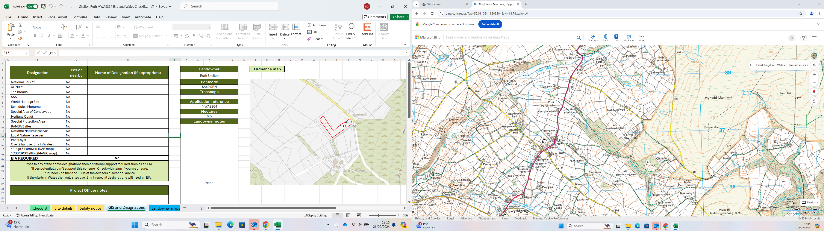

Site

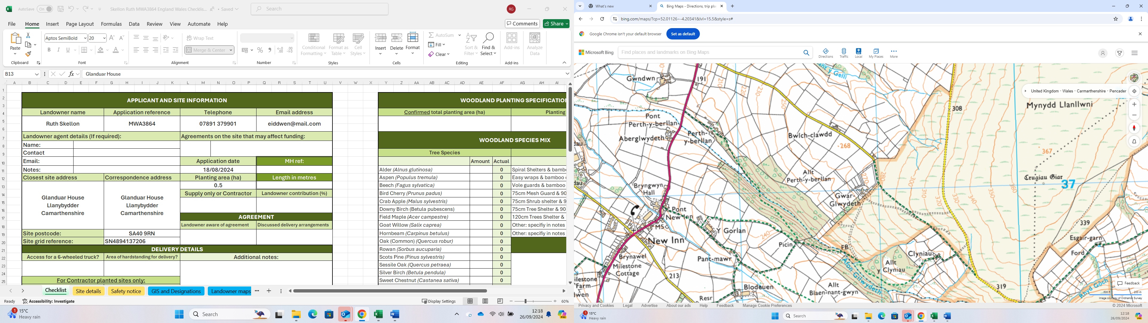

Site

