MWA4182 – J Parry, Hen Draws, Cilcennen
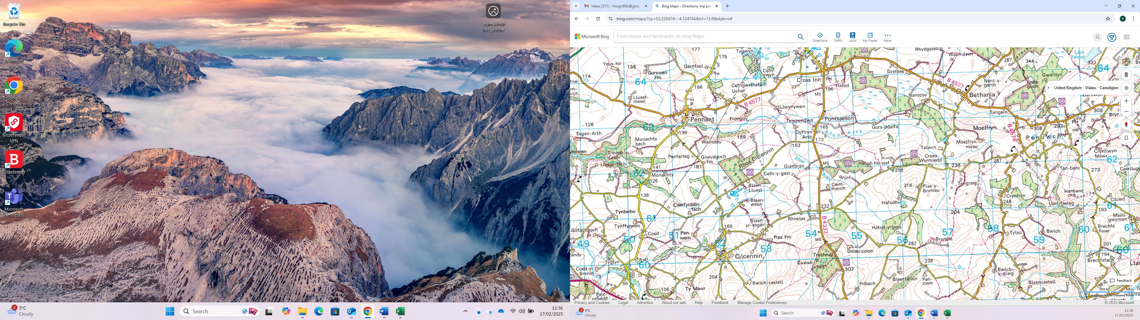
SITE

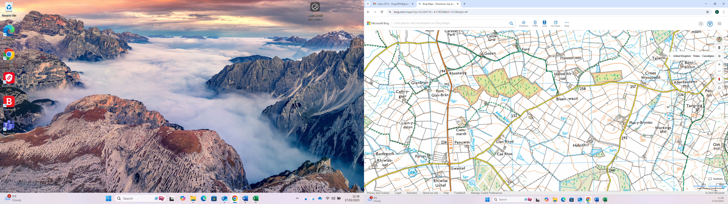
SITE

