MWA4165 – Map of Land at Llangolman – Miss E Thomas
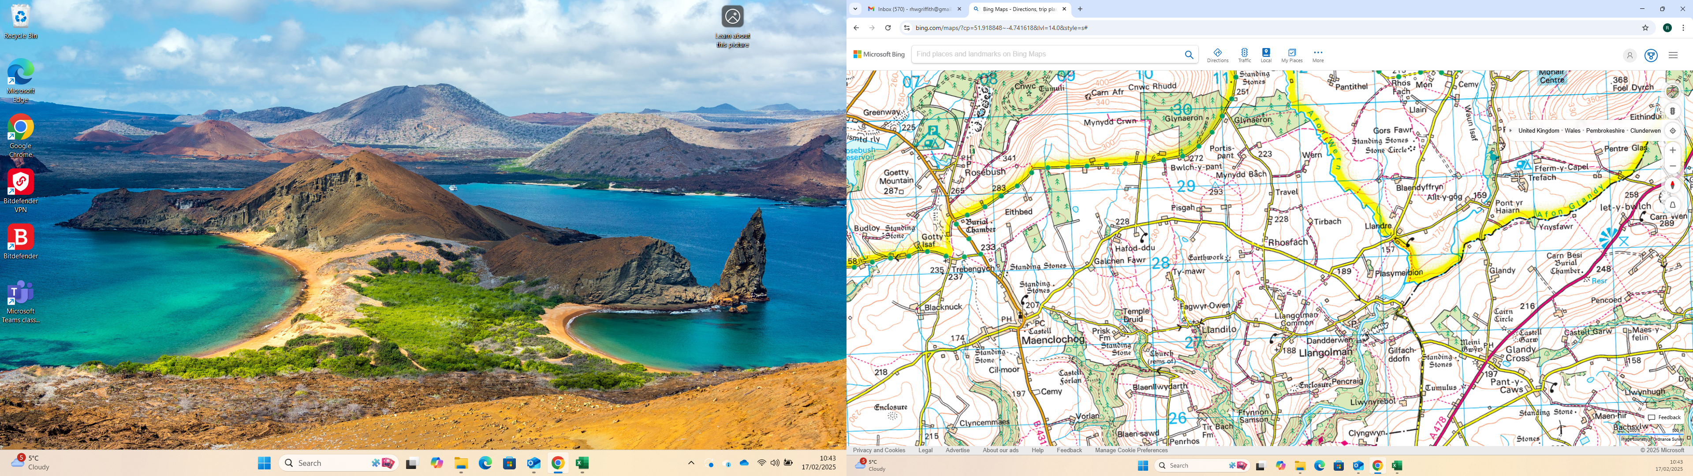
SITE

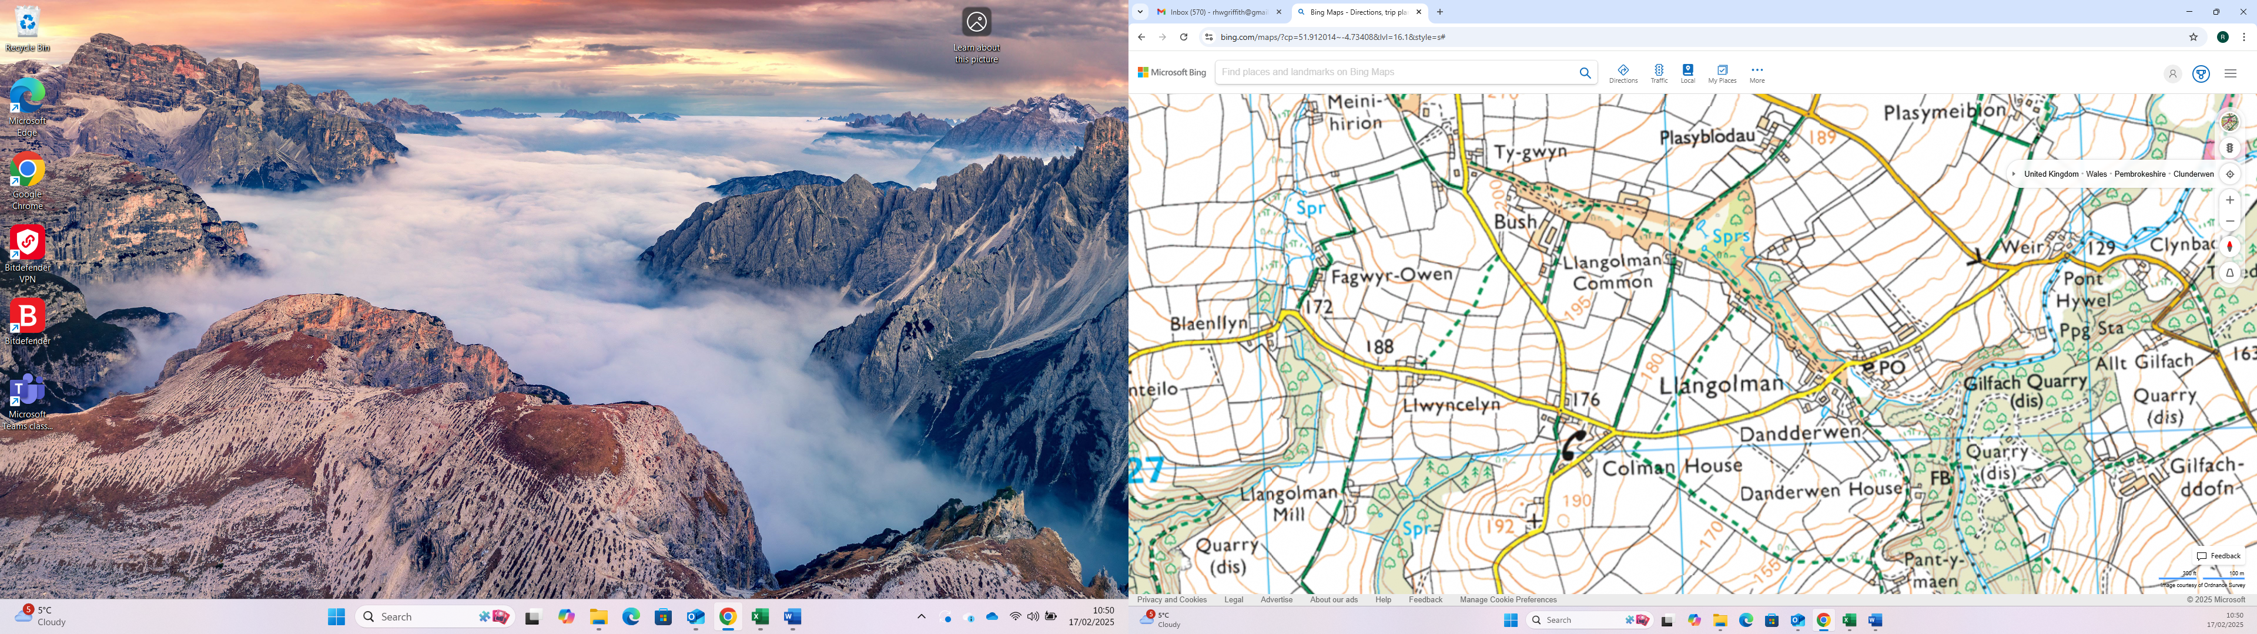
SITE

