MWA4178 HENEB CONSULTATION 26/2/25 - HW Forestry Ltd

Land at Whitland , SN201161 0.55ha Morewoods Native woodland

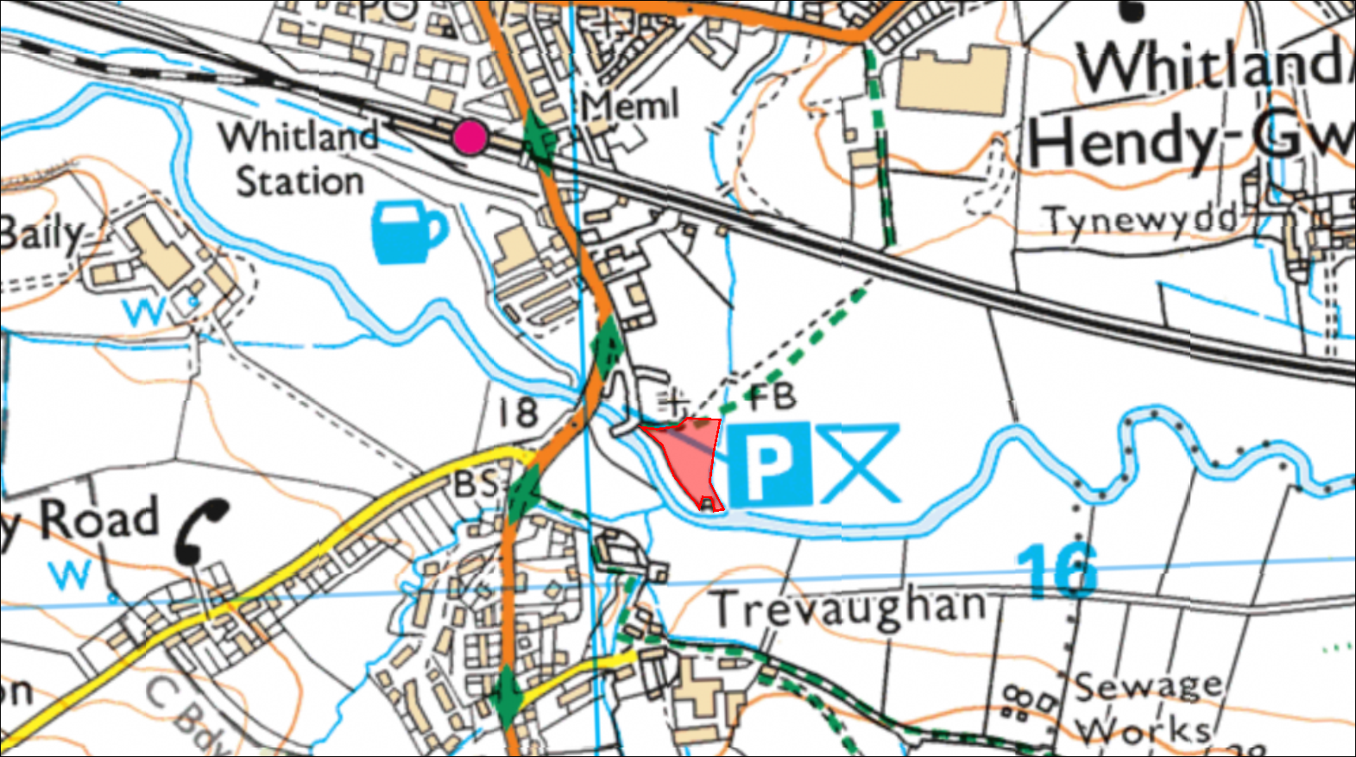
SITE

