DAT 14870

Russell Bayliss

Technical Support, Felling Permitting,

Natural Resources Wales,

Maes Y Ffynnon,

Penrhrosgarnedd,

Bangor,

Gwynedd,

LL57 2DW

26th November 2020

Dear Russell,

**FLA 354 20-21 Hean Castle Estate**

Thank you for your consultation. I have checked the map boundaries against the regional Historic Environment Record (HER) and other sources and note the following historic environment features recorded within the consultation area.

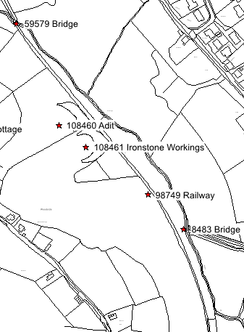

*Reproduced by permission of Ordnance Survey on behalf of HMSO © Crown Copyright and database right 2011. All rights reserved. Ordnance Survey License number 100017916*

|  |  |  |  |
| --- | --- | --- | --- |
| PRN | Summary | Type | NGR |
| 8483 | The bridge formed the crossing for a mineral railway from iron mines in the coastal deposits a few hundred metres to the southeast. The bridge operated with a causeway (8484). When the site was visited in 1979 only the masonry buttresses remained. MM Apr | Bridge | SN14510668 |
| 59579 | Grade II listed bridge | Bridge | SN1427806978 |
| 98749 | Part of the Saundersfoot Railway passes through the application area, now disused but still in use as a pathway.  The Saundersfoot railway was a 4 foot railway built in 1829 comprising two principal mineral railways and many side branches. The line close | Railway | SN14460673 |
| 108460 | An adit for iron ore mining associated with a large spoil tip (PRN 108461) on Sardis Mountain, Amroth. A Day March 2015 | Adit | SN1433506832 |
| 108461 | A large spoil heap associated with an iron ore mine (PRN 108460) on Sardis Mountain, Amroth. A.Day March 2015. | Spoil Heap | SN1437306800 |

The current condition of some of these features is unknown; however they may survive as ruins, earthworks or below ground archaeology. Felling operations should avoid causing damage in these areas.

There is always the possibility for previously unknown remains to survive within this area of which we have no knowledge. Should further archaeological features or finds be identified it is important that Dyfed Archaeological Trust Heritage Management is informed and further information and advice can then be provided as required.

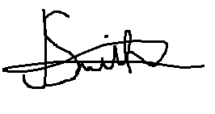

Jenna Smith

Heritage Management Archaeologist

01558 825995

j.smith@dyfedarchaeology.org.uk