Environmental Screening Advice Note

Screening completed by | Heulwen Baughn, Environmental Assessment Team (EAT)
Date | 29th April 2024

Project Name | Upper Clarach Catchment
Location | South east of Penrhyn-coch, east of Aberystwyth | Grid reference
  Mine Name | Grid Ref. | Proposed work
  CWMERFIN | SN 696 829
  DAREN (Daren United, Old Daren, Daren Olivers Addit) | SN 675 828 | Flow Gauge
  CWMSYMLOG (Daren East, Gwaithddu, Bushell’s Shaft) | SN 698 837 | Flow Gauge
  BRONFLOYD (Bryn Llwyd) | SN 659 835
  CEUNANT | SN 708 827
  BWLCH UNITED (Bwlch) | SN 703 824 | Flow Gauge
Senior User | TBC | Senior User Post Title
Project Manager | Tom Williams | Project Manager Post Title | Lead Specialist Advisor: Abandoned Mines
Community Risk Register Area (for FRM projects) | TBC | Strategic Context e.g. CFMP / SMP Policy, RBMP | WFD Water Quality Improvement
Set out the background, scope, description, and objectives of the project (information from project mandate)
Background:
The Clarach Catchment project is a programme of water quality and flow monitoring, desk studies, blow-out assessment and design of flow gauging structures at six metal mines in the Upper Clarach Catchment.

This project forms part of the Metal (Non-Coal) Mine Programme (MMP). The primary aim of the MMP is to improve water quality to meet the objectives of the Water Framework Directive (WFD).

There are two waterbodies that form the Clarach Catchment: Clarach - headwaters to tidal limit (GB110063041610) and Bow Street Brook - headwaters to confluence with Clarach (GB110063041630). Both of these waterbodies were ‘Moderate’ status in the 2021 WFD classification with the driving elements being metals from abandoned mines.

The Coal Authority’s 2020 Failing Waterbodies Assessment for the Clarach Catchment identified eleven ‘Red’ sites (known or highly likely to be impacting the water environment) and ten ‘Amber’ sites (which might be impacting, but need additional data to inform either way), concluding:
The most significant individual discharge currently identified is from the upwelling discharge to the Symlog associated with the Cwmsymlog/Darren East mine complex. Loading from the Erfyn is c.15% greater (for zinc) than that from the Symlog, most likely largely originating from Bwlch and Cwmerfyn, but also from other mines within the Erfyn catchment. Anecdotal evidence suggests that Bwlch Mine is the largest point source, although an uncharacterised discharge from Oliver’s Adit at Darren could also be significant. Other mine sites provide additional loading (unquantified, but likely minor compared to those previously noted) throughout the remaining river system.
Bow Street Brook inputs approximately 12% of metals to the river system. This loading should not affect the status of the downstream Clarach waterbody (GB110063041610) if all other metal inputs in the Clarach are mitigated. Alternatively, mitigation of Bow Street Brook inputs would reduce the mitigation requirements within the main Clarach waterbody (although principal identified discharges would still need to be addressed there also).
Further assessment was undertaken at Bronfloyd, Cwmerfyn, Llechweddhelyg, Mynyddgorddu and Vaughan by WSP in 2021 as part of the Catchments and Mines Project, commissioned by NRW. This included calculation of metal loadings which enabled further prioritisation of sites within the Clarach Catchment.

Proposed Project Work:
This project will focus on six mines on the Nant Erfyn, Nant Symlog and Nant Silo in the Upper Clarach, which are understood to contribute the largest loadings to the catchment.

The main project tasks include:
• Further water quality and flow monitoring to apportion metals sources and characterise mine water discharges;
• Desk studies at a further four sites;
• Blow-out risk assessment at two sites; and
• Options appraisal, design and construction of flow gauging structures on three point sources.

Flow gauges (FG) will be located at 3 points, as follows:
FG1: Daren Oliver’s Adit (SN 68041 83326)
FG2: Cwmsymlog (SN 69500 83787)
FG3: Bwlch (SN 69982 82580)

Scope of this screening advice note:
This screening foccusses on the design and installation of the 3 flow gauging structures listed above. The proposed water quality sampling is non intrusive and considered to be low risk and does not require formal screening, as are the desk study elements.

Please re-consult the Environmental Advisor if there is any change to the scope of the works outlined above.

It is noted that the project will require to be re-screened when it advances to the next stage once this flow monitoring and water sampling ‘problem identification’ stage has been completed. It is understood those works would be progressed as a new independent project.

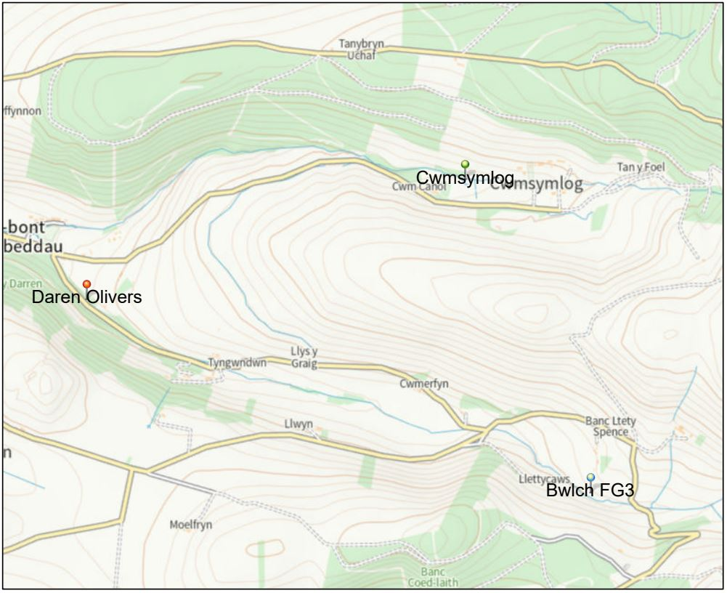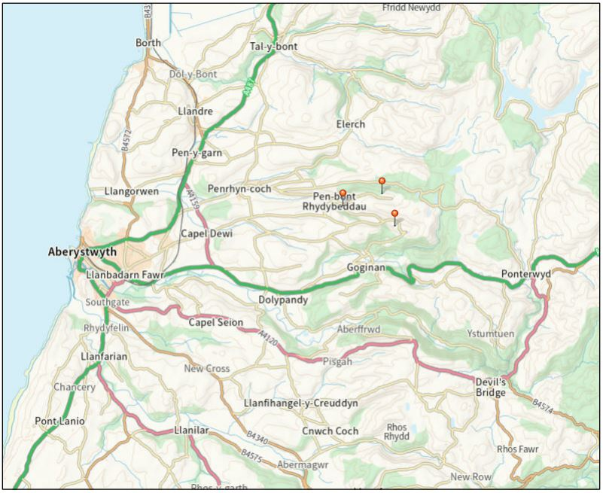
Figure 1: Flow Gauge Locations (Shown as Pins) Figure 2: Site Location (with Flow Gauge Locations shown as Pins)

Environmental Screening
 | Environmental Desk Based Assessment | Follow up Action Required | Who will carry out the follow up action? | Action Tracker
Key environmental receptors | Population & Human Health  There are a number of Public Rights of Way within the locality, some of which are in close proximity to the three flow gaugling locations, but is it not anticipated that these will be directly impacted upon by the installation of the flow structures.  There is an area of common land located 1.1km east of FG2 (Cwmsymlog) and 800m east of FG3 (Bwlch). Is is not likely to be impacted by the flow gauge work.  Biodiversity, Fisheries & Invasive Non Native Species  There are three SSSIs in the locality, as follows:  - Cwmsymlog SSSI is designated for dry heath and rare fern and is located 280m from FG2 (Cwmsymlog), 1.8km from FG1 (Daren Oliver’s Adit) and 1.2km from FG3 (Bwlch).  - Banc Llety-Spence SSSI is designated for dry moorland species with a mosaic of dwarf-shrub heath and acidic grassland. It is located 250m from FG3 (Bwlch), 560m from FG2 (Cwmslymog) and 2km from FG1 (Daren Oliver’s Adit).  - Mwyngloddfa Darren SSSI is designated for its mineralogy (particularly primary mineralization). It is located near to FG1 (Daren Oliver’s Adit) at a distance of just 50m, but is located on the adjacent side of a section of woodland and small road and therefore unlikely to impacted by the proposed flow gauge location. It is 1.8km from FG2 and 2.3km from FG3.  Calaminarian/metallophyte surveys have been undertaken near to all three flow gauge locations but none of the three proposed flow gauge locations fall within any areas of identified metallophyte habitats, or within any spoil heaps.  Refer to ‘Calaminarian Habitat Surveys in Ceredigion 2020 - 21, Natural Resources Wales Evidence Report No: 532’ for Daren Mine and  ‘A Survey of Calaminarian Grassland in Mid-Wales Natural Resources Wales Evidence Report No: 061’ for Cwmsymlog and Bwlch mines.  Survey results for the three areas are as follows:  - Daren Oliver’s: Report indicates historic mine area is highly disturbed by reprofiling of tips and encroaching forestry therefore very little metallophyte interest remained at this site with the exception of one National Rare species of Gyalideopsis crenulata that was frequent on the largest upper tip (located 120m SW of proposed Flow Gauge 1 location) and found on several quartz fragments (it is considered this represents the largest world population of this species). None of the other habitats present at Daren supported any metallophytes or calaminarian species.  - Cwmsymlog: Flow Gauge 2 is located outside the areas of spoil heaps surveyed as part of the report. Surveys found a mixture of good AM (Open stoney ground with metallophytes), BM (open Caliminarian grassland on spoil), FM (Buildings/structures with metallophytes) and HM (Caliminarian heath) habitats are present on spoil heaps, located approximately 270m east and 160m southeast of the proposed flow gauge (FG2) location.  - Bwlch: The report indicates that this mine was subject to a major reclamation in 1998-1999 and is now used for sheep pasture and only small areas of spoil remain, which are located approximately 300m southeast of the proposed location of Flow Gauge 3. Less than 800m² has Caliminarian interest with a small number of lichens and metallophytes found during the survey.  INNS – not known but could be present, particularly on rivers/streams and within forestry areas.  There is an Ancient Semi Natural Woodland located 20m downstream (southeast) of FG1, and a Plantation on Ancient Woodland Site located 10m south of FG1 (on the other side of an access road). There are no ancient woodlands located within 1km of the other two flow gauges.  Land (eg land take), Geology and Soils (eg organic matter, erosion, compaction, sealing)  The project area is a historical mining area and therefore contains a number of heavily contaminated spoil heaps and contaminated areas associated with the historical mines. Soil should therefore be considered and treated as potentially contaminated with metals and contamination testing should be undertaken if any excavation and material movement is required as part of the work.  The wider area supports sheep farming and forestry (coniferous).  Agricultural Land Classification at FG1 and FG3 is grade 4: Poor quality agricultural land. Land at FG2 is grade 5: Very poor quality agricultural land.  As detailed above, Mwyngloddfa Darren SSSI is designated for its mineralogy (particularly primary mineralization) and is located 50m southwest from FG1 (Daren Oliver’s Adit). However, there is a section of woodland and small road between the site and the flow gauge location, and therefore the installation of the flow gauge is unlikely to impact upon, or require access within, the designated site. It is located 1.8km from FG2 and 2.3km from FG3.  Cwmsymlog Mines Regionally Important Geodiversity Site (RIGS) is located 100m south and 270m east of FG2. It is located approximately 1km north of FG3, and 1.5km east northeast from FG1.  Darren Mine Geological Conservation Review (GCR) site is located 50m southwest from FG1.  Water (eg hydromorphological changes, quantity and quality)  The upper Clarach catchment contains one WFD river: ‘Clarach headwaters to tidal limit’ (GB110063041610), which extends throughout the catchment study area and covers the Nant Silo and Afon Erfyn as well as the downstream Nant Clarach, and runs adjacent to FG1 and FG3.  Nant Symlog which flows from Llyn Pendam, past Cwmsymlog and FG2 and joins into Nant Silo downstream of FG1, does not form part of this WFD but is a tributary to it.  The WFD waterbody is classified as Moderate quality with failures for a number of metals (cadmium, lead and zinc).  Flow gauge structures are located on smaller inflows and tributaries rather than directly on the WFD waterbody / main river.  The watercourses become Main River at Pen-bont Rhydybeddau (where the Afon Erfyn and Nant Symlog merge, 360m downstream of FG1). The three proposed flow gauge locations are on ordinary watercourses.  Air  None anticipated given scale and nature of the work.  Climate (eg greenhouse gas emissions, impacts relevant to adaptation)  None anticipated given scale and nature of the work.  Landscape  The project area is located within the Upland Ceredigion Historic Landscape Area.  Cultural Heritage  A number of Scheduled Ancient Monuments (SAM) are located within 1km of the project area, namely:  SAM number CD144 ‘Daren Lead Mine Workings & Adit’ is located 230m southwest of FG1 (and 1.7km southwest from FG2 and 2km west from FG3).  SAM number CD028 ‘Daren Camp’ is located 280m southwest of FG1 (and 1.7km southwest of FG2 and 2km west of FG3).  SAM number CD159 ‘Cwmsymlog Lead Mine’ is located 380m east of FG2 (and 1.2km north of FG3 and 1.9km east northeast of FG1).  SAM number CD201 ‘Blaen Cwmsymlog Lead and Silver Mine’ is located 870m east of FG2 (and 1.3km north of FG3 and 2.4km east northeast from FG1).  SAM number CD056 ‘Castell S of Goginan-Fach’ is located 830m southwest of FG3 (and 1.9km southeast from FG1 and 1.9km south from FG2).  A number of other SAMs are located between 1km and 2km of the flow gauges including: CD065 Carn Dol-Gau; CD027 Camp near Garth-Penrhyn-Coch; CD152 Bronfloyd Leadmine; CD178 Lluest Pencraig Ddu Deserted Rural Settlement; CD069 Pen y Castell.  There are a number of listed buildings within the catchment area. However, none of the three flow gauges are thought to be within the footprint or curtailage of any of these listed buildings (none are within 150m) nor impact upon their settings.  Nearest listed buildings to each flow gauge are:  FG1: The Old Post Office, Penybont House and Darren Villa are between 240-300m from FG1.  FG2: Cwm Canol, Tabernacle Baptist Chapel, Plas Wigwam and Cwmsymlog Mine chimney are between 165m and 445m from FG2.  FG3: Capel Siloa (chapel house and attached front walls) is located 270m from FG3.  Material Assets  The proposed flow gauge locations are all on privately owned land. | Population & Human Health (Recreation)  If PRoW closures/diversions are required for the construction of the flow structures, liaise with Local Planning Authority Public Rights of Way officer.  Biodiversity, Fisheries & Invasive Non Native Species  It is recommended that a Preliminary Ecological Appraisal (PEA) be undertaken of the three proposed Flow Gauge locations and any access routes, by appropriately qualified ecologists, to determine whether any protected and priority species are present. This should also include checks for any Invasive Non Native Species.  CRoW (SSSI) Assent is not anticipated to be required for the flow gauging structures in their current proposed locations as they are outside the designated areas, however this should be confirmed through consultation with NRW’s Ceredigion Environment Team, and also with Bob Mathews in relation to Mwyngloddfa Daren SSSI (for mineralogy) (also refer to Geology section below).  If any work or access is required within the SSSIs areas then Assent may be required and the Ceredigion Environment Team should be consulted.  Consult with Sam Bosanquet (NRW Lower Plants Specialist Advisor) if any work is proposed within areas of mine spoil due to the possibility of lower plants/Calaminarian grassland being present. However, it is noted that none of the three proposed flow gauge locations are within areas of spoil nor within any areas that have been highlighted as having Calaminarian interest in previous surveys.  Land, Geology & Soils  The proposed works do not involve significant earthworks. Any areas of excavation should be assessed for contamination risk and managed accordingly. Consult with NRW’ Geoscience Team (geoscience@cyfoethnaturiolcymru.gov.uk). if any significant earthworks are included at a later date to confirm any testing and/or other requirements.  If any work or access is required within the Mwyngloddfa Daren SSSIs area then Assent may be required and the Ceredigion Area Environment Team and Bob Mathews should be consulted.  Consult with Bob Mathews if any works are proposed within the Cwmsymlog RIGS and/or Darren Mine GCR site.  Water (inc WFD)  Ordinary Watercourse Consent may be required for the works. Confirm with Local Authority.  Consult with Oliver Lowe (Geomorphology) in relation to flow gauge designs and locations to understand and prevent potential impact on geomorphological processes within the catchment.  Consult with Ceredigion Area Environment Team to confirm whether WFD assessment is required for the flow structures.  Consult with Flood Risk Analysisto confirm whether Flood Risk Activity Permit is required.  Appropriate mitigation to be implemented during installation of flow structures to ensure pollution prevention control and mitigate risk of pollution of watercourses at and downstream of the works. This should be documented and implemented through an Environmental Action Plan (EAP) for the flow gauge installation work.  Air  None anticipated.  Climate  None anticipated.  Landscape  None anticipated.  Cultural Heritage  Liaise with Heneb the Trust for Welsh Archaeology (formerly Dyfed Archaeological Trust) (contact: planning@heneb.co.uk) and Cadw to confirm that no impact to nearby SAMs and confirm no Scheduled Monument Consent is required for the installation of the three flow gauges or for any of the survey work.  A Historic Environment Screening has been requested from Heneb and the response will be added to this ESAN when received.  Material Assets  Obtain landowner consent for installation of flow gauges and access for any survey work. | Project Manager  Project Manager  Project Manager  Project Manager  Project Manager  Project Manager | To be completed by PM to document whether action has been completed. Advice Note should then be used as supporting document when applying for project approval (e.g. submissions to Project Approval Board / Programme Board).
Likely consenting route | Proposed installation of flow structures is not likely to require planning consent.  Work is thought to fall under NRW’s Permitted Development Rights as stipulated by Part 15 of the General Permitted Development Order. .  The scale and nature of proposals do not require a statutory Environmental Impact Assessment and an Environmental Statement. However, as the flow gauging structures are likely to be deemed improvement works rather than maintenance, there will be a need to advertise NRW’s decision not to produce an environmental statement. | Whilst not a legal requirement, confirmation as to whether Permitted Development applies can be sought from the local planning authority.  In accordance with the EIA (Land Drainage Improvement Works) Regulations there is a statutory requirement to advertise NRW decision not to produce an Environmental Statement. Please contact NRW’s Environmental Assessment Team for a copy of the advert template and guidance on where to advertise and on those that must be notified. The advert must be in place for 30 days prior to works commencing. | Project Manager
Other approvals required | Likely to be required:  - Ordinary Watercourse Consent  Possibly required:  - CRoW (SSSI) Assent  - Flood Risk Activity Permit  - Protected Species Licencing  - Scheduled Monument Consent |  | Project Manager
Environmental opportunities | In delivering our projects we should consider what wider benefits we can deliver, for example:  - Are there any opportunities for using green engineering / green infrastructure? |  | Project Manager | Ensure any benefits delivered are reported to the benefactor and to the communications team for publicising.

A map highlighting some of the scheme constraints has been included within Annex 2.
Record of all consultation responses can be found within Annex 3.

Screening Conclusion

- Following internal consultation, it has been determined that this project is medium risk not likely to lead to significant environmental effects provided that good working practices and any additional mitigation identified is implemented. Unless the project scope changes, this project does not require Environmental Assessment Team (EAT) involvement.

- This note has been prepared to assist the project manager (PM) in taking forward actions and in documenting this for project approval purposes. The PM can seek assistance from local Environment Team for specific tasks identified in Table 2, which must be agreed as part of the project planning stage. If at any point the scope of the works changes from that described above, the project manager must contact the local Environment Team to confirm whether a revised determination is required.

- The project manager is responsible for ensuring the follow up actions are undertaken to ensure the environmental risk is managed. It is recommended an Environmental Action Plan is produced for the project to set out the environmental requirement to be delivered and adhered with. The EAP should be embedded withing the contract/works information for the main contractor.

Annex 2: constraints plans

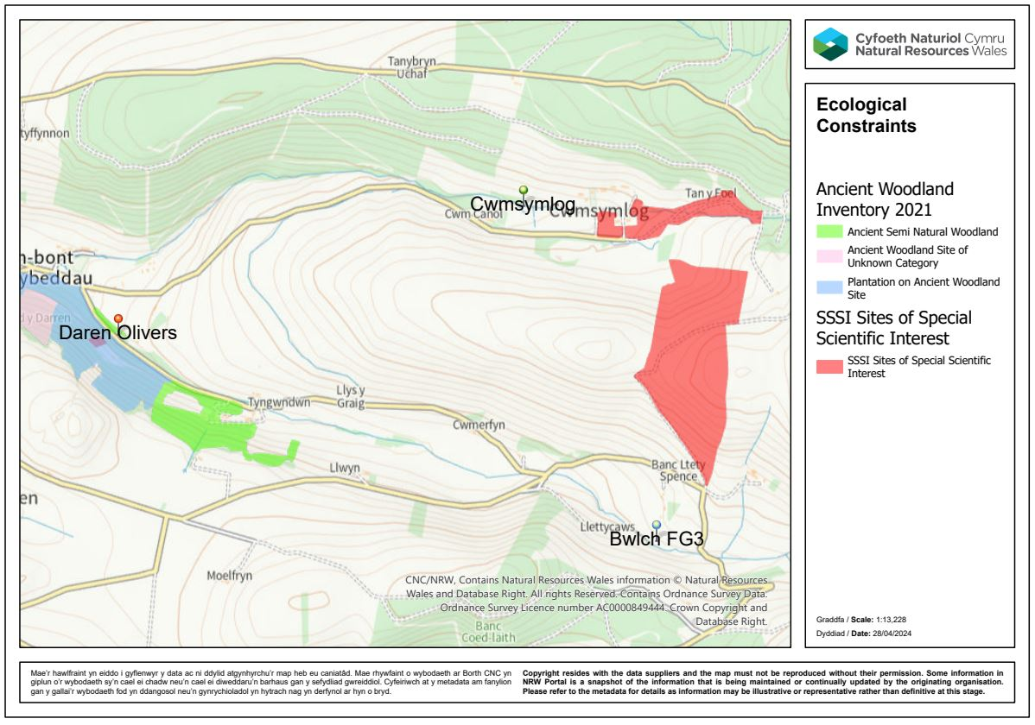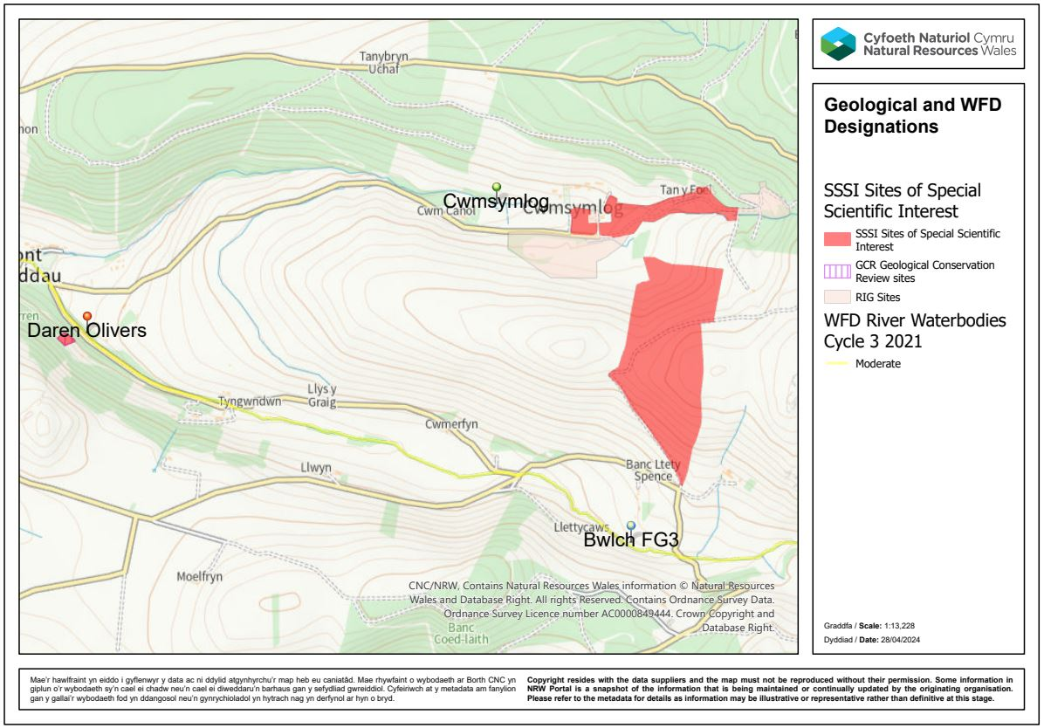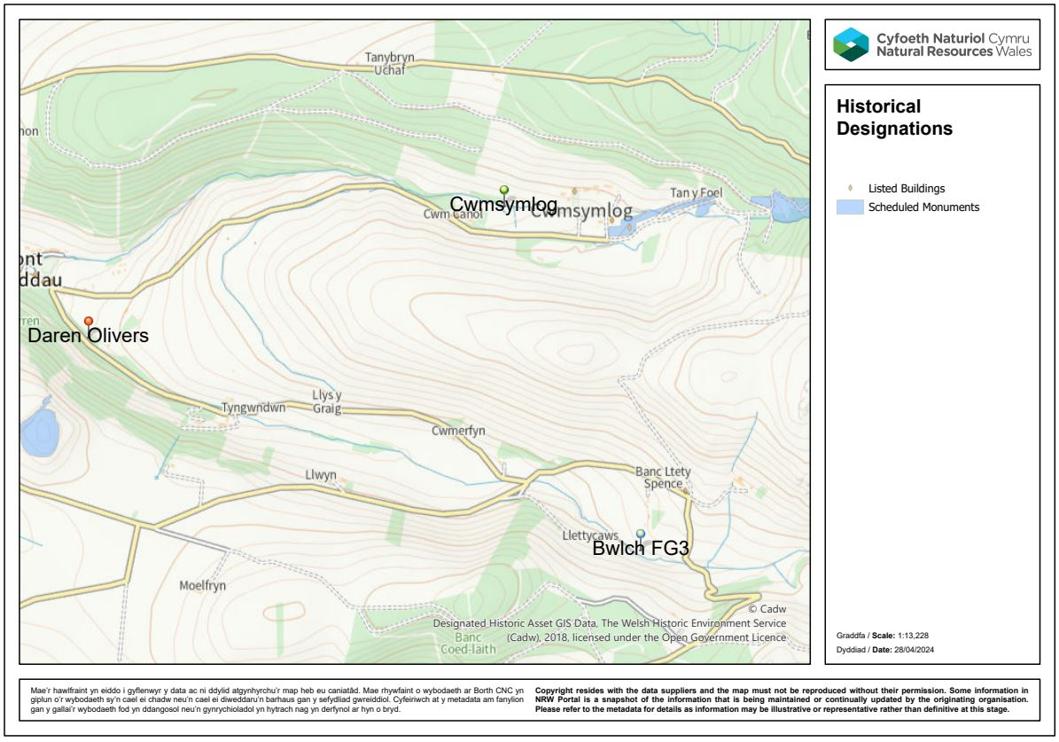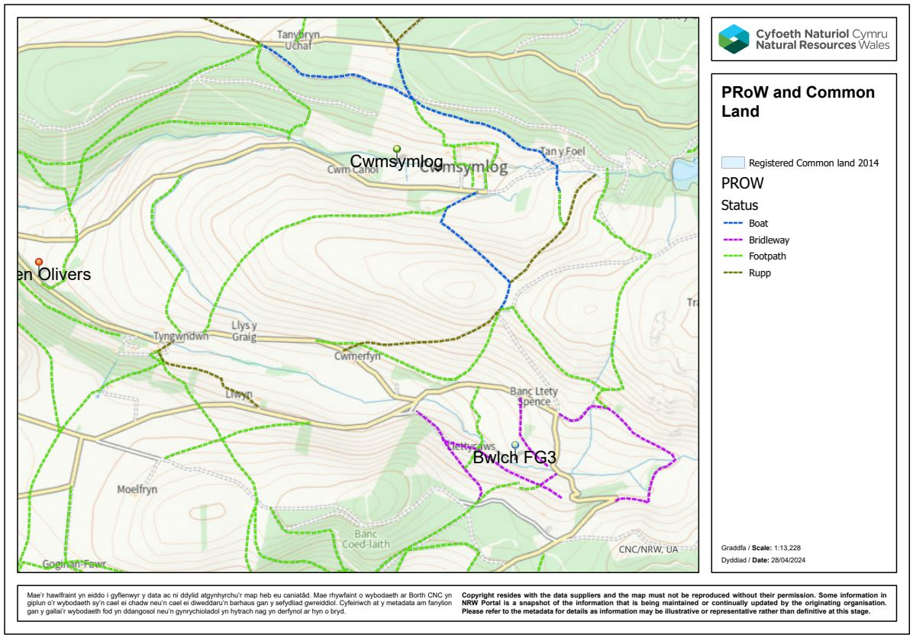

Annex 3: parties consulted in the screening
Name | Function | Date issued | Response received | Comments Received | Action taken to address comments
Steve Meaden | NRW Health Policy Team (HIA)
Alice Pyper / Felicity Sage | Heneb (previously Dyfed Archaeological Trust)
Carol Fielding | Ceredigion Environment Team
Bob Mathews | Geology
Sam Bosanquet | Lower Plants
Oliver Lowe | Geomorphology

