Environmental Screening Advice Note

Screening completed by | Joshua Gittins
Date | 27/11/2020

Project Name | Ritec Culvert Repairs, Tenby
Location | Tenby, Pembrokeshire | Grid reference | SN 1287 0035
Senior User | Darren Walsh | Senior User Post Title | Team Leader, Asset Performance
Project Manager | Eva Neville | Project Manager Post Title | Projects Delivery
Community Risk Register Area (for FRM projects) | 4059 – Tenby/Dinbych-y-pysgod | Strategic Context e.g. CFMP / SMP Policy, RBMP | CFMP Policy 4 and SMP 20 (Lavernock Point to St Ann’s Head), Policy Units 16.12, Managed Realignment (Epoch Policy 20, 50 & 100).
Set out the background, scope, description, and objectives of the project (information from project mandate)
Project Background
The Tenby FRM system is drained by the main River Ritec and tributary Knightston Brook together with the ordinary watercourse drainage network. The Tenby system is located within Policy Unit 4 of the Pembrokeshire and Ceredigion Rivers CFMP where the preferred policy is to take further action to sustain current scale of flood risk into the future responding to the potential increases in flood risk from urban development, land use change, and climate change.

Flooding has occurred within this FRM system on several occasions including: October 1977, August 1997, January 2003 and October 2004. Tent and touring van pitches at Kiln Park were flooded in November 2005 and January 2008 with static caravans flooded in November 2009.
Flooding occurred most recently on 25th March 2020 when a peak tide level of 6.93m CD was recorded at Milford Haven. On Friday 27th March areas of surface heave/movement were identified indicating that a likely partial collapse of the Ritec Culvert had occurred in the section between the Railway Line and the South Beach car park. Currently the culvert is still able to convey fluvial flows through this section.
There are concerns over the long-term integrity of the masonry culvert, which was installed in the 1860s. If the culvert is left unattended and failed completely it is likely that there would be both fluvial and tidal flooding impacts. There are a significant number of properties at fluvial flood risk upstream of the Tidal Flap Valve located at the culvert inlet. It is also likely that if the culvert blocked completely and was unable to take fluvial flows that water would impound on the Railway line.

The lower Ritec enters a 350m long masonry arch culvert at an inlet chamber at the Salterns (Quarry Cottages). The inlet chamber houses a trash screen and tidal flap and is located immediately northwest of the main Tenby to Pembroke railway line. The masonry culvert has two intermediate chambers and terminates at the South Beach penstock chamber (12.3m deep). From there it continues in a cast iron pipe, with HPPE extended length and discharges direct to the sea.
The 12m deep South Beach valve chamber provides the connection between the masonry culvert and the cast iron outfall and includes automated penstock). Closure of the penstock reduces upstream tidal flood risk caused by the ingress of tidal water, however the penstock needs to be opened at low tides to allow flows along the Ritec to discharge into the sea and to reduce the risk of upstream flooding. Parallel to the masonry culvert is Dwr Cymru Welsh Water’s (DCWW’s) 530mm diameter combined sewer which leads to the 1800mm diameter tank sewer, both of which should no longer be in use. A 415m long cast iron/HPPE outfall (1.2m diameter) extends offshore from the South Beach valve chamber below Tenby South Beach. Below is the current outfall plan:
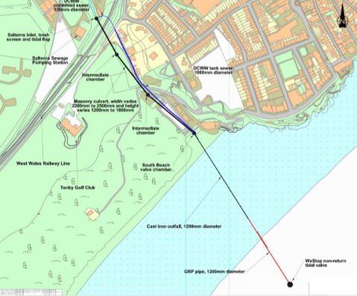

The following forms a list of historic interventions at the proposed site:
• Following the March flooding event, it was identified that the Wastop non-return valve was not operating correctly to prevent tidal ingress. Diving operations were conducted in June to replace this valve.
• In May new monitoring telemetry equipment was installed upstream of the Salterns grid.
• Refurbishment works to the masonry culvert were undertaken by Birse (now Balfour Beatty) between April 2012 and April 2013 which involved repointing, re-grouting and replacement of masonry blocks.
• GRP extension at offshore end of outfall: The lower section (180m) of the cast iron pipe was replaced with a GRP pipe, completed on 24th April 1996 at a cost of £600,000, funded by DCWW.
• In 1997 work was undertaken on the Cast Iron outfall to remove a crust of thick scale and a carbon layer approx. 20mm thick. The thickness of sound metal ranged from 34mm to 42mm.
• In 2014 NRW commissioned Halcrow, a CH2MHill company, to investigate the performance of the existing culvert/ outfall system and develop and appraise a wide range of long term interventions.

If the culvert was left unattended and failed completely it is likely that there would be both fluvial and tidal flooding impacts. Collapse of the masonry culvert will prevent the River Ritec from discharging into the sea, water will pond inshore of the Salterns inlet with no means of drainage, and will flood several assets, increasing the risk of slippage/ failure of the railway embankment, which is not designed to act as a flood defence.
A draft preliminary flood damage assessment has been undertaken, using both the FRAW Economic Tool and Welsh Government’s Rapid Assessment of Damages Tool (RAD) to estimate the economic damages for various scenarios. This document identified that a complete failure of the culvert could result in damages circa £6M. In this scenario a total of 33 properties, including an ambulance station, are identified at risk in this flood envelope. This assessment does not take full account of damages accruing at Kiln Park, which is a major economic centre for Tenby, or any potential damage caused to the railway line so is considered conservative.

• There is strong evidence to suggest the main masonry culvert has partially failed downstream of the railway line and the flow capacity is likely to be reduced. Given nature of ground it is reasonable to assume any failure could deteriorate rapidly.
• Tides above soffit level of culvert, caused by the previously non-operational wastop valve, may have caused further loss of surround, destabilising the culvert, particularly since the original tidal flap was moved from the South Beach valve chamber to the Salterns.
• The condition of the cast iron length of outfall hasn’t been internally assessed since 1997. Therefore, it is possible that scale and carbon build up may be reducing the capacity of the pipeline and cracking in the pipeline joints may be allowing water to penetrate.

Scope & Description of Works
The work included in this mandate will involve but not be limited to:
• Collation and review of existing documentation and data.
• Plan and procure survey works to determine the condition of the existing assets and nature and scope of short term and long term interventions, including;
o Inspection to confirm existing condition and residual life of masonry culvert.
o Inspect the condition of the 12m deep valve chamber, to include the condition of shaft, grills, ladders, electrical equipment and penstock.
o Detailed inspection/ camera survey of cast iron outfall to identify cracks or flaws in the joints between the pipeline sections, identify any build- up/deposits in the pipeline, Non-destructive Ultrasonic testing of the wall thickness.
• Undertake debris clearance, if appropriate.
• Assess the damage and estimate current asset life.
• Compile report of suggested repairs to improve the integrity of the existing culvert and estimate the asset life extension.
• Carry out costing of suggested repairs.
• Develop a project communications plan and co-ordinate liaison with key stakeholders and affected parties.
o Confirm with Dwr Cymru Welsh Water whether the tank sewer is still operational and whether it could be reconfigured to enable water to be pumped offshore in emergency circumstances.
o Consult with Network Rail on suggested culvert repairs in the section of masonry culvert beneath the railway embankment which is in their ownership.
o Coordinate with NRW teams to agree survey works and isolations.
o Engage with external stakeholders including local residents and Kiln Park.

The project is seeking to understand the current condition and asset life of the Ritec outfall and associated assets. This project will determine what repairs can be undertaken and what the life of the asset could be extended to.
Once the condition of the culvert has been understood a decision will be made on what works may form part of a medium term and longer-term intervention.
All work will be co-ordinated by the Projects and Programmes Delivery team. Specialist contractors will be engaged to undertake survey works under this mandate.

Environmental Screening
 | Environmental Desk Based Assessment | Follow up Action Required | Who will carry out the follow up action? | Action Tracker
Key environmental receptors | Population & Human Health  The current asset runs under a number of residential properties along Battery Road, including a car park and the Festival of Britain beacon (Listed Building). Tenby South Beach is also an extremely busy recreational area. Tourism in Tenby is a main focus of the economy with attractions such as Caldey Island, Tenby Museum and Art Gallery, and Tudor Merchant’s House drawing nearly 90,000 tourists throughout an average year alone.  The Pembrokeshire section of the Wales Coastal Path crosses above the current asset at two points. Depending on the project works a potential diversion may be required. Across the catchment upstream of Tenby town, there are a number of other Rights of Way footpaths.  Biodiversity, Fisheries & Invasive Non Native Species  The current asset discharges into the Carmarthen Bay and Estuaries SAC, which extends out into Carmarthen Bay SPA and the Bristol Channel Approaches SAC. The asset also runs in-between (and less than 100 m from) the Tenby Cliffs and St Catherine’s Island SSSI, and the Lydstep Head to Tenby Burrows SSSI.  The Local Record Centre have evidence of priority and protected species in the area of the current asset and the catchment upstream. In particular, certain mammals (otter, badger, polecat, weasel hedgehog; and myotis, daubenton’s, natterer’s, pipistrellus, soprano pipistrelle, brown long-eared, greater and lesser horseshoe bats), birds (e.g. black-headed and herring gull, song thrush, Cetti’s warbler, house sparrow, dunnock, hoopoe and goldeneyes), amphibians (e.g. common frog and toad, and palmate newt), reptiles (grass snake and slow worms), insects (e.g. small blue, dingy skipper and small heath butterflies, and cinnabar and shaded broad bar moths) and plants (e.g. sea stock and bluebells). The area is also thought to contain Invasive Non-Native Species (designated for: Canada goose, Austrominius crustaceana and Poryphera algae, and grey squirrel).  Upstream of Tenby town along the Ritec and some of its tributaries, there are some areas of Ancient Semi Natural Woodland. To the Northeast of Tenby town there is also an area of Restored Ancient Woodland.  There are no Sites of Interest for Conservation or Local/National Nature Reserves within the vicinity of the current asset or the proposed scheme.  Land (eg land take)  The land-use surrounding the asset is a combination of residential (fringe of Tenby town) and tourism (Kiln Caravan Park), transport network (railway), some shrubland, beach, and a golf course. Upstream adjacent to the Ritec and its tributaries there is agricultural land (majority grade 3a and b, and 4, with some grade 2).  It is anticipated that limited, if any, additional land will be required for this culvert repair, however, if the scope of the works change and more land is required then this should again be screened for its environmental impact.  Soils (eg organic matter, erosion, compaction, sealing)  The current asset is located adjacent to the Tenby Cliffs Geological Conservation Review Site.  There are no current landfill sites operating within the vicinity of the asset, however, the Salterns Historic Landfill site is adjacent to the lower reaches of the Ritec, approx. 100 m upstream of the asset. Further, Clicketts Lane, Tenby Marsh and Trefloyne Farm historic landfill sites are within approx. 2 km of where the Ritec is culverted. The risk of contaminated soils is highest along the bank of the Ritec and its tributaries in the Clicketts area.  Water (eg hydromorphological changes, quantity and quality)  The River Ritec is at overall ‘Moderate’ WFD status, and there is a WFD monitoring station (chemistry) just above the culvert. The Ritec drains into Carmarthen Bay, which is classified as a Moderate’ status coastal waterbody under the WFD.  The potential scheme will likely feature works below and above the Mean High Water mark. Due to the nature of the project, it is set within a high-risk flood area.  Air  There are no known Air Quality Monitoring Stations situation near the proposed project site.  It is anticipated that there will be little to no effect on the local area’s air quality from this project.  Climate (eg greenhouse gas emissions, impacts relevant to adaptation)  Under changing climates, the fluvial and coastal risks of flooding to the residents and businesses of Tenby could be exacerbated. This project looks to address one of the current risks to the community from damaged infrastructure.  Landscape  The current asset is entirely contained within the Pembrokeshire Coast National Park.  The asset is not situated within a Historic Landscape or an Area of Outstanding Natural Beauty, but is within the South Pembrokeshire Coast National Landscape Character Area and the Carmarthen Bay and Estuaries Marine Landscape Area.  Cultural Heritage  There are a large number of Listed Buildings within Tenby town and the surrounding catchment. In particular, the current asset is only within close proximity to the Festival of Britain beacon, a grade II Listed Building.  The town of Tenby is a designated Conservation Area, in addition to Penally and Scotsborough House Conservation Areas in the wider Ritec catchment. There are four Scheduled Monuments (SMs) within (and proximate to) the Tenby town (Fort St Catherine, Tenby Castle, Tenby Market Cross and Tenby Town Wall). None of these SMs are within 350 m of the current asset, but there are five more SMs in the wider Ritec catchment (Black Rock Quarry Lime Kilns, Little Hoyle Cave and Longbury Bank Dark Ages site, Scotsborough House Ruins, the Watchtower and Holy Mouth Cave).  Project groundworks should fall within the existing asset footprint (see land, geology and soils section in this Screening).  Material Assets  The proposed repairs are located on the culverted lower reaches of the River Ritec with residential and business properties immediately at the beginning of the asset. The Ritec runs under the railway line which is the line between Pembroke Dock to Swansea and on to south east Wales and England. Potential utilities within the area need to be identified.  Correct waste management procedures should be undertaken; the PM should be familiar with any necessary waste licencing requirements and contractor checks must be done | Population & Human Health (Recreation)  The Project Manager (PM) should consider any construction-phase impacts on nearby properties, e.g. noise, vibration, light etc. Appropriate working hours to be agreed (for contractor or in-house Operations team) with Pembrokeshire Coast National Park Authority (PCNPA) and/or Pembrokeshire County Council (PCC) in advance to mitigate any issues relating to construction disturbances. Minimise the footprint and confirm the construction compound requirements going forward.  The closest properties to the scheme should be informed of the scheme early, in addition to engagement with any relevant landowner(s), to ensure considerate traffic planning and minimise disruptions.  Dependent on the scope of the scheme and potential risks to the population and human health, Health Impact Assessment (HIA) screening should be discussed with NRW’s Health & Wellbeing team (steven.meaden@cyfoethnaturiolcymru.gov.uk).  Consult with PCNPA’s Rights of Way officer and the NRW Wales Coastal Path team for the area to discuss the scheme’s impact on the Wales Coastal Path and other Rights of Way.  Given the location of the project community engagement will be required and opportunities should be sought for the delivery of wider benefits.  Biodiversity, Fisheries & Invasive Non Native Species  It is recommended that an Extended Phase I Habitat survey be undertaken by an ecologist, to detail the habitat and vegetation types and whether the priority and protected species and INNS recorded by the LRC are still within the vicinity. This will inform seasonal working plans, but due to the potential presence of breeding birds in the area protected under the Birds Directive 2009, works should not be carried out between April and August. The local Environment Team’s fisheries advisors should also be contacted to advise with regards to appropriate mitigation and/or working conditions to avoid disrupting fish stocks or migration. Also, during this phase, consult PCC and PCNPA regarding any TPOs due to Tenby’s Conservation Area status.  A Habitats Regulations Assessment will be required for the proposed works at this site and should be built into the programme and budgets. There is potentially a need for a Coastal Squeeze Assessment to support any HRA for this project. The PM/Environmental Lead should consult with Rick Park / Nikki Rimington / Emmer Litt for further information on a Coastal Squeeze Assessment. Also, INNS/biosecurity good practice should be adhered to. Discuss these matters and the ecological surveys with the Pembrokeshire area Environment Team (Robert.phillips@cyfoethnaturiolcymru.gov.uk).  SSSI assent is likely to be required, NRW’s SSSI team should be consulted to confirm this (SSSI.notices@cyfoethnaturiolcymru.gov.uk). Note that a section 28H SSSI assent is not required if a Flood Risk Activity Permit (FRAP) is granted for the project.  See PCC’s current Local Development Plan (LDP) and the update coming in 2021, and PCNPA’s LDP2 .An agreement between both Local Authorities will be required as to who leads on which parts of the project.  Geology & Soils  The type of repair work will almost certainly involve groundworks to access the buried culvert. Geosciences should be consulted once the plans for these groundworks have been finalised (geoscience@cyfoethnaturiolcymru.gov.uk). Correct waste management procedures should be followed. Refer to and follow relevant Guidance for Pollution Prevention (for Wales, Scotland and NI), specifically PPG 1, 5, 6, 21 and 22.  Regarding the construction compound and access, the compound footprint should be minimal, with mitigation in place to protect soils from damage (e.g. compaction etc.). Any additional access requires should be constructed as temporary and the reinstatement of initial land-use should take place post-works.  Water (inc WFD)  WFD Preliminary Assessment (screening) is required. Consult with the area Environment Team (Robert.phillips@cyfoethnaturiolcymru.gov.uk) who can advise on the scope of the Preliminary WFD Compliance Assessment. Consultation with the area geomorphologist (Dale.Cox@cyfoethnaturiolcymru.gov.uk) should also be undertaken regarding potential immediate and knock-on impacts to the riverine and riparian form and processes within the reach and to identify any SMNR opportunities to improve/restore the river environment and/or work with natural processes (WWNP).  Water and sediment quality management is important to undertake with care to prevent pollution. Appropriate mitigation will be required to minimise fine sediment (i.e. silt and clays) pollution and the correct management of any fuel/oils during construction should be undertaken. The sediment and water quality management procedures should be outlined clearly in the project Method Statement. The Method Statement and Environmental Action Plan should be communicated to the local Environment Team and the EAT.  The works must not increase flood risk and should be planned and timed to minimise the risk of flooding affecting construction – ideally, the construction plant (and any materials) should be stored outside of the floodplain. These works will require a FRAP (Part A: Flood risk activity 3c: Erecting or altering any structure designed to contain or divert flood waters of a main river - Flood risk activity definitions (April 2016) GPG 220). A Flood Consequences Assessment (as per TAN 15) may be required once a long-term solution has been found. The local Flood Risk Analysis team should be consulted regarding this.  A marine licence is not required for an activity carried out by, or on behalf of Natural Resources Wales for maintaining coast protection works, drainage works or flood defence works. A licence is also not required for an activity carried out by or on behalf of the coast protection authority (usually the local authority) for the purpose of maintaining coastal protection works. The exemption is subject to the condition that the activity is carried out within the existing boundaries of the works being maintained. It does not apply to any activity that consists of beach replenishment. This is covered by Article 18 of the Marine Licensing (Exempted Activities) (Wales) Order 2011. However, if the works are not set within the direct footprint of the old asset, then a Marine Licence will likely be required due to the outfall discharging below the Mean High Water Springs (MHWS) line. See Annex 1. Contact the Marine Licensing Team at the earliest opportunity for advice re exemptions or licences.  Air  N/A  Climatic Factors  Project designers should consider potential opportunities for better local climate change adaption (e.g. minimise GHG emissions, using low-carbon material, offset tree/shrub planting for shade and green engineering options rather than materials with high carbon footprints as well as taking opportunities to restore the natural environment so as to increase carbon sequestration) and sustainable resource management.  The project’s carbon usage needs consideration through both the design and construction phases. Lower carbon design options and materials should be considered early.  Landscape  Given the sensitivity of the location in relation to landscape, early consideration must be given to how the asset fits in the local environment. Land and seascape character should be considered as the project options progress – EAT’s Landscape Architect (Marianne.jones@cyfoethnaturiolcymru.gov.uk) has been consulted and the Senior Landscape Advisor (Olwen.Maidment@cyfoethnaturiolcymru.gov.uk) for the area will be, due to the sensitivity of Tenby town as a Conservation Area (see Cultural Heritage section below).  Cultural Heritage  Listed Building consent may be required if works are undertaken within close proximity to the Festival of Britain beacon, unless avoidance measures can be put in place to prevent any effects on the building or the surrounding land. Early discussions with the Local Planning Authority (LPA) and Cadw will be required. Consultation regarding the proposed works being on the edge of a Conservation area will also be required with the local authority Conservation Officer. Scheduled Monument consent is likely to not be required.  There is potential for unknown archaeological finds where groundworks are undertaken.  The Dyfed Archaeological Trust (DAT) will be consulted regarding the sensitivities in the area surrounding this project, and will advise on any further constraints.  Material Assets  Progress a utilities search of the project area.  Consult with local NRW (Environment Officer) and Waste licencing team. The Waste licencing team can advise on the Definition of Waste (Code of Practice and Exemptions). | PM/EAT  EAT  EAT  EAT  EAT  EAT  EAT  EAT  PM | Actions to be included in the consultant scope for the project to inform the environmental assessment that will be required
Likely consenting route | Maintenance or improvements to existing culverts are likely considered a “permitted development” under the Town and Country Planning (General Permitted Development) order (2015), schedule 2. We do not expect planning permission to be required for this scheme but the LPA (i.e. PCC/PCNPA) must be consulted to confirm this due to the sensitivity of the Carmarthen Bay and Estuaries and its European designations, it’s setting close to a Conservation Area and location adjacent to a Listed Building. Conservation Area Consent and/ or Listed Building Consents are possibly required which would mean that NRW’s “permitted development” rights may be lost – close consultation with the LPA is required to determine the correct consenting route for this. If the LPA does confirm that the project is “permitted development”, the advertisement of this project screening will be necessary under the under the EIA (Land Drainage Improvement Works) Regulations 1999, as the project is likely to be considered a land drainage ‘improvement’.  However, if the project progresses to a wider catchment capital works scheme and/or Natural Flood Management project, then this will require further screening under the EIA regulations to determine if a statutory EIA is required (terrestrial or marine). More detail on the scheme is required to better assess the environmental risk of this project. The project team should liaise with EAT as potential scheme options arise and with the Marine Licencing Team early in the project progression.  The repair works will be carried out on the River Ritec which drains into the Carmarthen Bay and Estuaries SAC and in-between two SSSIs (Tenby Cliffs and St Catherine’s Island, and Lydstep Head to Tenby Burrows). However, these repair works alone are not expected to exceed the screening threshold of 1 ha for a statutory EIA. If this changes, discuss the consenting route further with EAT. Despite this, Habitat Directive (94/43/EEC), SSSI regulations and WFD Directive (2000/60/EC) constraints do exist for the site of the proposed scheme (HRA, SSSI assent, and WFD Preliminary Assessment required). An Environmental Action Plan will be required to ensure the correct mitigation measures are in place to protect biodiversity and water quality. To emphasise, the consenting route for this project should be reviewed by EAT once a preferred option has been selected. |  | PM
Other approvals required | - HRA  - SSSI Assent  - FRAP  - WFD Preliminary Assessment  - Coastal Squeeze Assessment  - Marine Licence or exemption – Further information can be found within Annex 1. |  | PM
Environmental opportunities | In delivering our projects we should consider what wider benefits we can deliver, for example:  - Can your project build in measures to slow the flow of water, consequently having flood risk and water quality benefits?  - Where associated with water courses can your project deliver Water Framework Directive benefits e.g. bank naturalisation, treatment of Invasive Non Native Species, hydromorphological improvements etc.?  - Where associated with Natura 2000 sites, can your project deliver any actions required under the Prioritised Improvement Plans?  - Are there any opportunities for using green engineering / green infrastructure?  - Can recreational or access opportunities be delivered through your project?  - Are there any opportunities for planting trees or shrubs?  - Are there any opportunities to promote simple changes to land management to provide food, shelter and nest sites for pollinators?  - Are there any opportunities for habitat improvement or creation, paying particular attention to resilience (connectivity, diversity, condition) of habitats within or linked to the study area?  - Are there any opportunities for community engagement or education?  - Are there any opportunities to improve fish habitat or passage? |  | EAT | Ensure any benefits delivered are reported to the benefactor and to the communications team for publicising.

A map highlighting some of the scheme constraints has been included within Annex 2.
Record of all consultation responses can be found within Annex 3.

Screening Conclusion

- Following internal consultation, it has been determined that this project may lead to significant environmental effects, depending on the scope of the works progressed, however, more detail on the scheme is required to better assess the environmental risk of the project. At this stage, it is suggested that EAT should be involved in this project.

Annex 1: Marine License

Marine Licensing
In broad terms a Marine Licence is required for any deposit, removal, construction or dredge operation below MHWS out to 12 nautical miles using a vehicle, vessel or marine structure, (Marine and Coastal Act 2009).

Some activities have been exempted from the need to have a marine licence. (The Marine Licensing (Exempted Activities) (Wales) Order 2011). These may include coast protection, drainage and flood defence works. The Marine Licensing Team require notification of these activites, which are then kept on a Register.

To determine whether the works to be undertaken require a marine licence or can be registered as exempt, please contact the Marine Licensing Team at: Marinelicensing@cyfoethnaturiolcymru.gov.uk.

The issue of a marine licence or registration of an exempt activity does not absolve an operator from gaining any other relevant consents or permits.

Annex 2: constraints plans

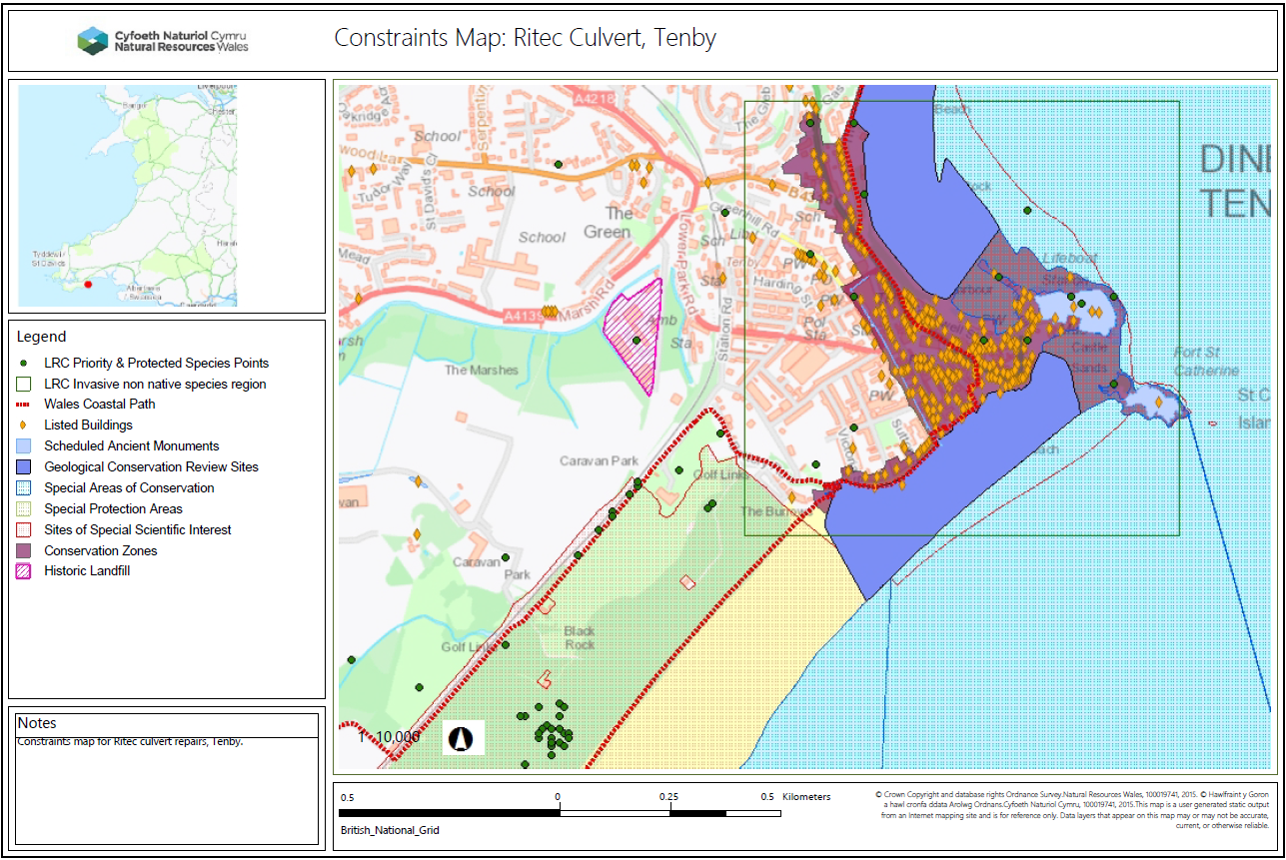
Constraints map of Tenby town and culverted area of the Ritec.
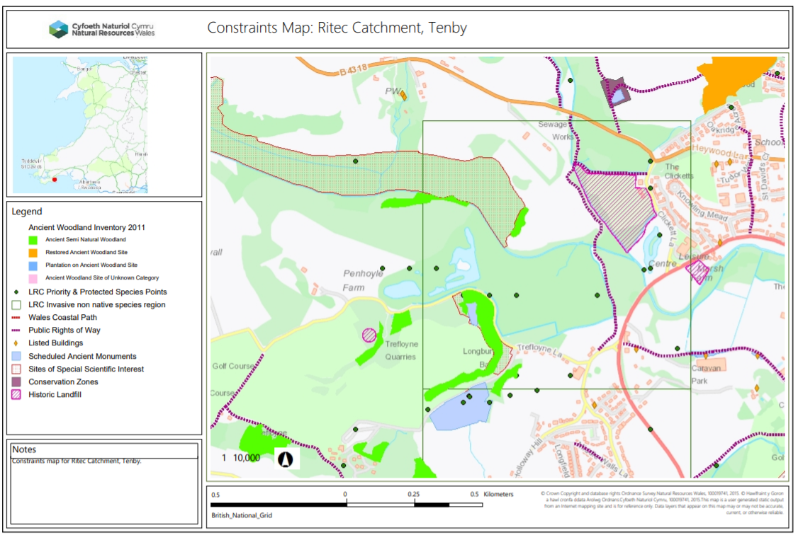
Constraints map of Ritec catchment, upstream of Tenby town.

Annex 3: parties consulted in the screening
Name | Function | Date issued | Response received | Comments Received | Action taken to address comments
Robert Phillips | Local Environment Team | 01/12/2020
Helen Milliband | WFD Area Coordinator | 01/12/2020
Dale Cox | Area Geomorophologist | 01/12/2020
Olwen Maidment | Landscape Architect | 01/12/2020
Alice Pyper | Dyfed Archaeological Trust | 01/12/2020
Steve Meadon | Health & Wellbeing Officer | 01/12/2020

Background Paper for Local Development Plan 2: Tourism. Pembrokeshire County Council, September 2019.

