**Dolaucothi Goldmines Block:**

**Options for harvesting in the SAM Area**

## Summary

The Dolaucothi Gold Mines block is an 11.6ha woodland which is leased by Natural Resources Wales from the National Trust. A large proportion of the site is designated as a Scheduled Ancient Monument due to the presence of Roman aqueducts and extensive workings associated with the adjacent Roman goldmine.

Japanese larch is the main species type in this block and covers 8.4ha. In May 2017 the larch was found to be infected with Phytophthora Ramorum and a Statutory Plant Health Notice (SPHN) was issued. The larch was subsequently stem-injected with Glyphosate in February 2018 to ensure compliance to the SPHN.

NRW have worked closely with CADW to identify an appropriate working method for the safe removal of infected trees, whilst ensuring the protection of scheduled features on site.

A large roadside strip outside of the scheduled area was felled in 2020, and subsequent felling of the remaining area has commenced in 2021. This operation has seen the site divided according to scheduled status, with the non-scheduled area being felled first.

There are currently only very limited options for machine access in the scheduled area which means that most of the trees will need to be felled by hand, cut to length and winched in bundles across the site to a skyline pad. Timber would then be moved a further three times before landing at roadside. Some of the timber in the west of the site would need to be winched over the aqueduct feature, which would be protected by a log bolster. There is a corner of the site that would not be accessible using this method, so trees would likely be felled and left in situ.

In the scheduled area there are a number of large edge trees on the fence line that are leaning away from the desired direction of fell.

An option for access by machine over the National Trust fields above the site is currently being signed off, which would enable the directional felling of the large edge trees.

An option to work the scheduled area in a safer and more efficient manner using machine access is explored below, along with other possible options.

## Options for access

### Option 1: Access over National Trust Land and travel through wood to temporary brash pad

Access over National Trust land has been agreed in principle and is currently going through the legal agreement.

The location of the proposed access is shown in maps 1 & 2 below.

The proposal is to access the wood through the stock fence and to create a level surface for a machine to travel to a brash pad. The proposed machine access would run from Point A to Point B (shown in map 2) and is approximately 25m in length. The route travels through well-spaced small larch trees.

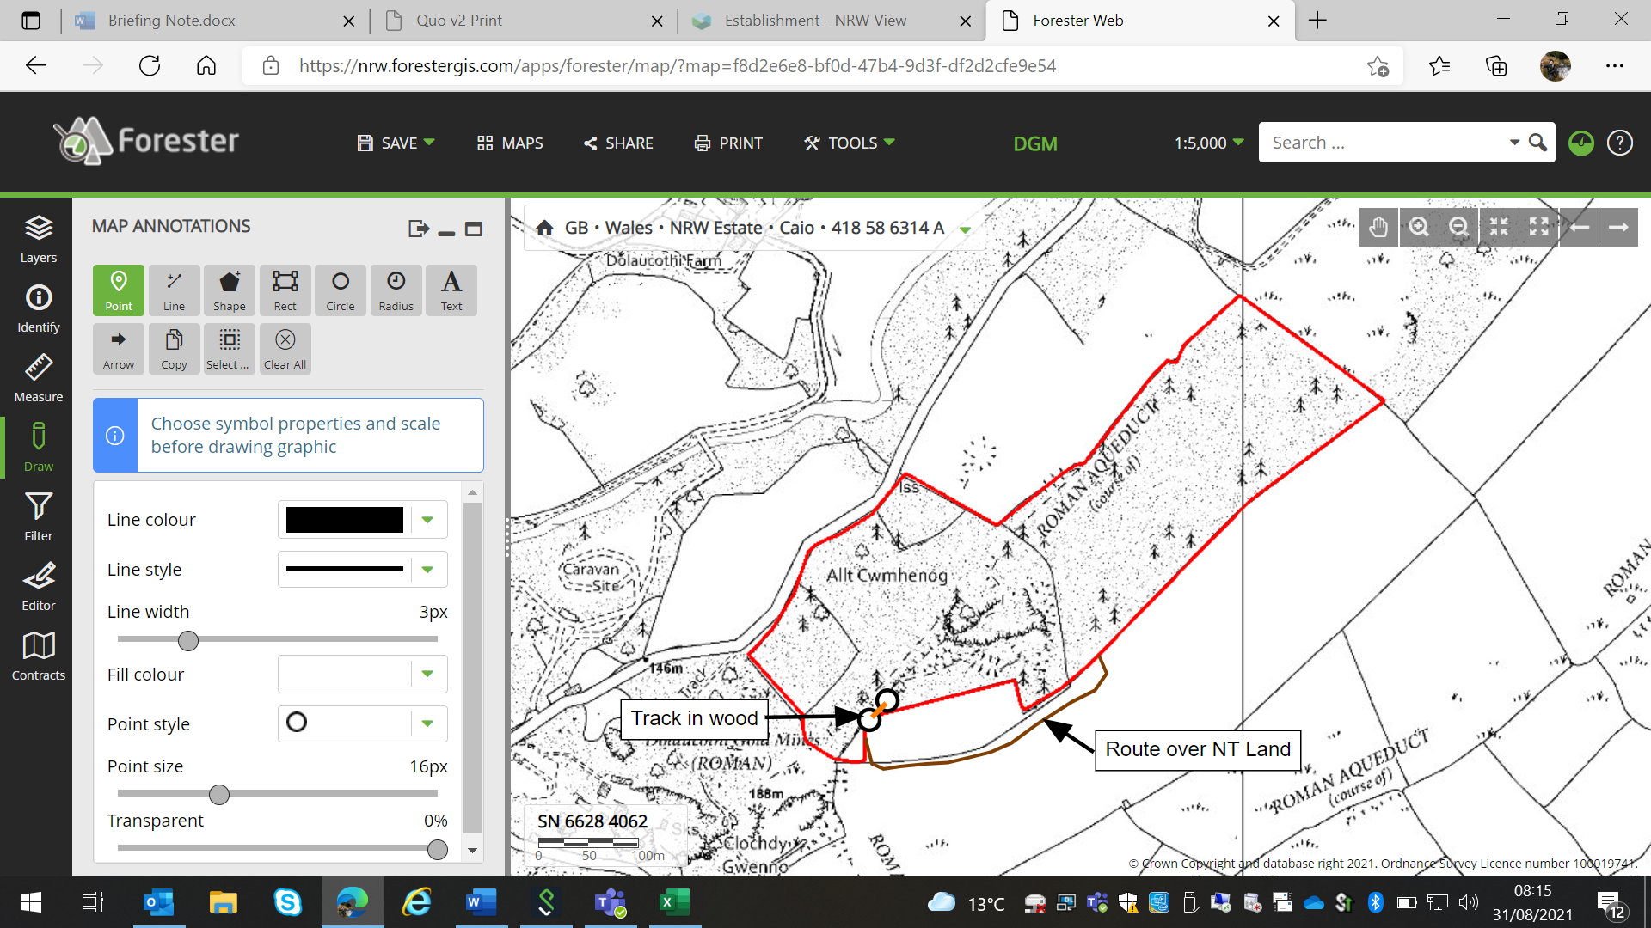

Map 1: Route over NT land and location of proposed machine access in wood.

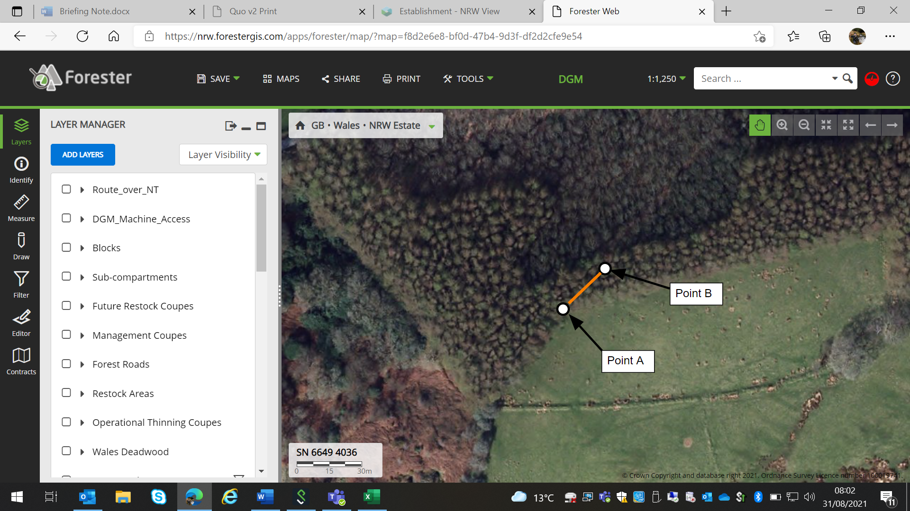

Map 2: Location of proposed machine access in wood with aerial image.

This access and brash pad would allow a greater area of the site to be felled and processed by the harvester, which has ‘falling objects protection’. Timber outside the reach of the harvester would be felled by hand and sky lined to the brash pad for processing. Processed timber would be sent straight down the site in the stillage container, several metres above the scheduled features.

#### Access construction

Most of the trees that are obstructing access can be cut off very low at the base. A total of six trees have been identified as needing to be removed down to the root. Four of these are very small and are located along the access route. The two remaining trees are at the brash pad and would be considered to be ‘medium’ sized trees.

The reason for needing to remove the root is that the side slope is sufficiently pronounced that running a machine wheel over a stump at that point could cause the machine to become unstable.

All trees that need to be ‘pulled’ have been sprayed with the letter ‘P’. Those that need to be cut have been sprayed with a letter ‘C’.

There are two methods that can be used to remove the trees at the root:

* 1. Pull the tree out of the ground using a harvester machine.
  2. Dig the roots out using an excavator.

It is the opinion of the contractor that each of these options will yield a very similar result. Due to the structure of the root, the digger option (b) is unlikely to produce a clean ‘slice’ through the soil. It would however lead to less mixing of soil, so could be a preferable option.

The trees to be pulled are shown in the photographs below with a spray can for scale:

#### Four small trees to be pulled to create level surface:

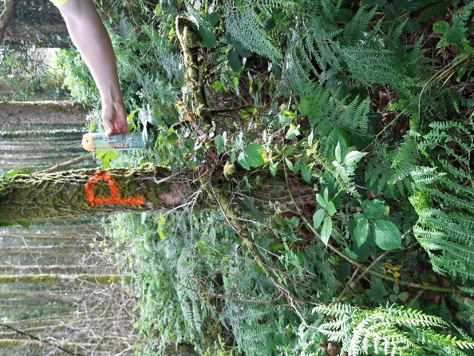

#### Two medium trees to be pulled at Skyline pad area:

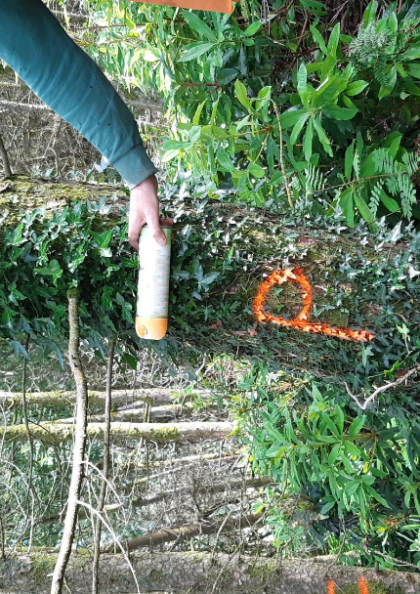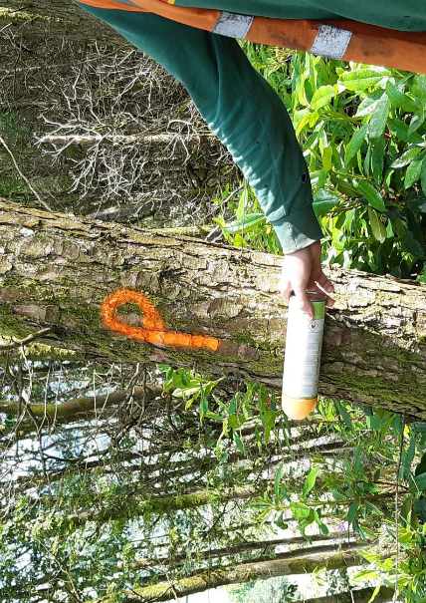

#### Advantages to Option 1:

* Reduce the handling of timber, in turn reducing risk to health and safety.
* More of the trees can be felled using a harvester with falling objects protection, reducing risks to chainsaw operators.
* Timber can be lifted over archaeological features, reducing the risk of damage.
* Large and leaning edge trees can be pulled in the desired direction of fell, minimising the risk to health and safety and of damage to National Trust land.
* More trees on the site can be accessed for extraction, minimising timber left in situ.

#### Disadvantages to Option 1:

* Disturbance of soil in scheduled area.
* Long travel over National Trust land.

## Option 2: Access over National Trust Land to fence line.

Access would be taken over National Trust Land and access into the wood made through the fence as shown in Map 1.

The machine would not travel any further into the wood and would be located just inside the boundary. The machine would be used to assist with directional fell of large edge trees using an offset winch.

#### Advantages to Option 2:

* Large and leaning edge trees can be pulled in the desired direction of fell, minimising the risk to health and safety and of damage to National Trust land.
* No disturbance of soil in scheduled area.

#### Disadvantages to Option 2:

* Long travel over National Trust land with small gain.
* Corner of site may not be accessible and so trees may need to be felled and left in situ.
* High level of timber handling increases the risk to health and safety.
* Some timber will need to be dragged over feature at designated crossing points which will be built up with a log bolster. This could pose a risk of damage to the features.

## Option 3: Continue with current agreed working method

This option is to continue with the method as agreed in the CADW Management Plan.

#### Advantages to Option 3:

* No disturbance of soil in scheduled area.

#### Disadvantages to Option 3:

* Edge trees will be difficult to fell and may have to be felled into National Trust field, causing mess and ground damage.
* Corner of site may not be accessible and so trees may need to be felled and left in situ.
* High level of timber handling increases the risk to health and safety.
* Some timber will need to be dragged over feature at designated crossing points which will be built up with log bolsters. This could pose a risk of damage to the features.

## Conclusion

Option 1 would be the preferable outcome for NRW when all of the costs and benefits are considered. Both CADW and the National Trust would also benefit from the wider prevention of ground damage in areas where features are present.

It is understandable that the movement of soil in a scheduled area is not usually permitted, but this is an exceptional site and any works carried out could be completed under a watching brief.

For further information, please contact:

Caroline Riches MICFor

Senior Officer Forest Operations

Natural Resources Wales

caroline.riches@naturalresourceswales.gov.uk