Method statement for Flood Risk Activity Permit applications for deployment of water quality passive sampling devices
All passives samplers will be deployed Jan 25th 2025 to Jan 25th 2026. Proposed passive sampler deployment location(s):

Llanybydder (Afon Teifi) SN516440 (E 251698 N244081 SA40 9UG)

The passives are housed in a small cage and have no moving parts or electronics. They are deployed to absorb chemicals onto a silicone strip, within the cage. The diameter of the cages is just over 21cm and they are 15cm in height.
See below for pictures of the devices, tethers and how the are deployed.

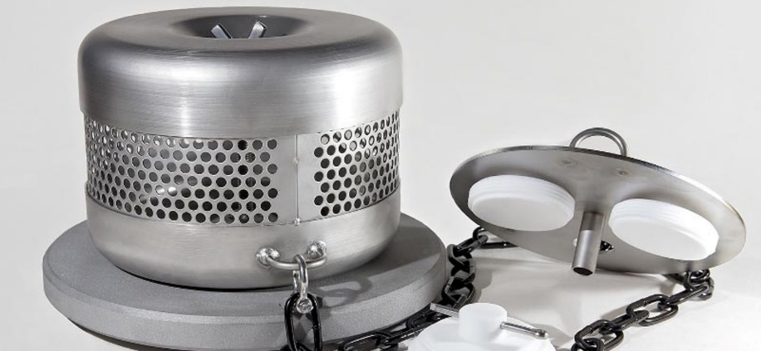
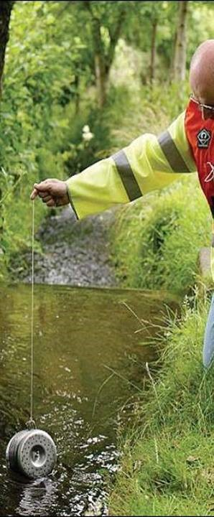

They are in place for 4 weeks at a time, and replaced with new silicone strips after this period.

The passive devices are tethered to a tree root or similar, and sit on the bottom. But they do move about on the end of the tether, in line with flow etc…

Devices are deployed for 3 to 4 weeks then replaced with another. The total duration of the deployments at these locations will be 12 months.

Site specific photographs are included below;

- Llanybydder (Afon Teifi) ;

