**Dukes Meadow – Pendine**

Closest Post Code: SA33 4PF  
Grid Reference: SN 23700 08191

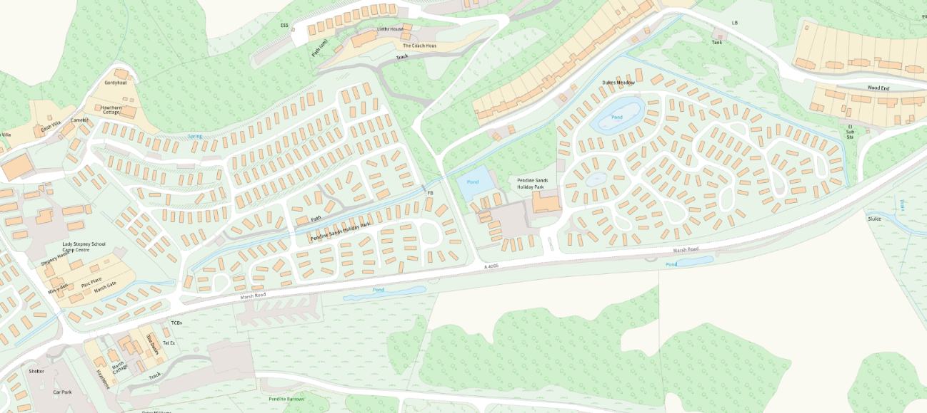Closest Post Code: SA33 4UH  
Grid Reference: SN 24155 08426

Length of river not being maintained

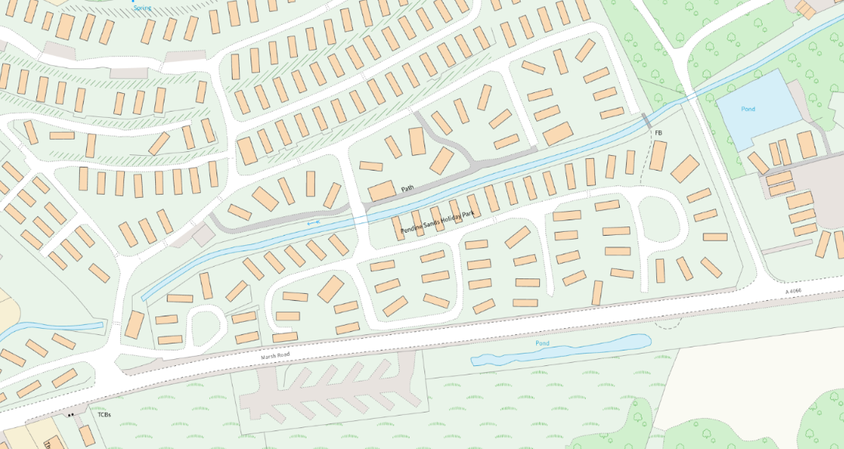

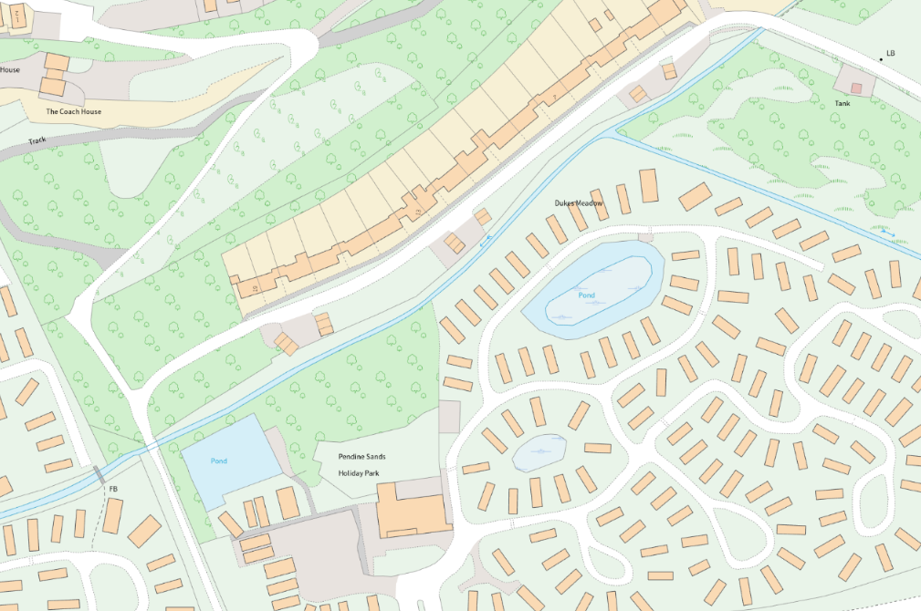

**Dukes Meadow – Pendine**

Length of river currently maintained by NRW