**REACTIVE MAINTENANCE SCHEDULE**

**Task Description:** Mechanical Waterway Management

**Task Code/Plan Reference:** FR19S219/001/PDM

**Created on date:** 01/10/2024 **By name**: Peter Morgan

**CYFOETH NATURIOL CYMRU**

Plas Gwendraeth

Cross Hands Business Park

Carmarthenshire. SA14 6RE

**SYSTEM INFORMATION**

**FRM System No.:** FR19S219

**Watercourse Name:** Abergwili Mill Leat & Bwlch Stream

**System Risk:** M



Reproduced by permission of Ordnance Survey on behalf of HMSO. © Crown Copyright and database right [2018]. Ordnance Survey licence number 100019741.

Atgynhyrchwyd â chaniatâd yr Arolwg Ordnans ar ran Llyfrfa ei Mawrhydi. © Hawlfraint a hawliau cronfa ddata’r Goron [2018]. Rhif Trwydded yr Arolwg Ordnans 100019741.

**LEGEND**

Potential compound location 🔒

Grid Ref.: SN 43451 21033

Potential loading/unloading location Ⓟ

Grid Ref.: SN 43451 21033,

Potential assembly area 🚑

Grid Ref.: SN 43451 21033

**SITE PLAN:– Location:** Abergwili **NGR:** SN43228 20598 to SN43610 21370 **Postcode:** SA31 2JA

**LOCATION PLAN**

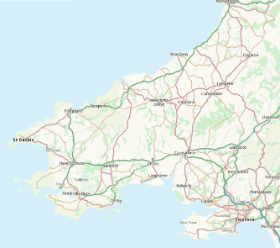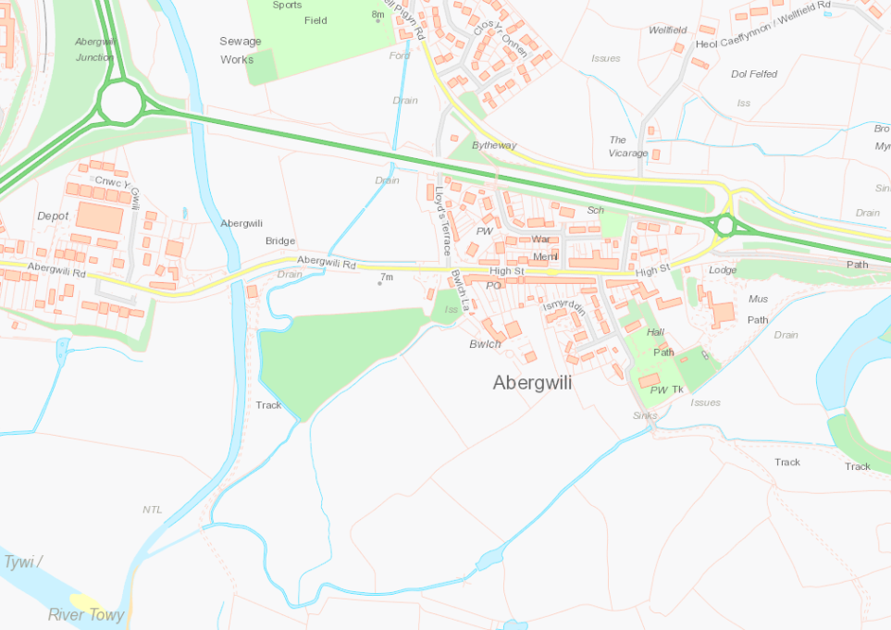

Mechanical Waterway Management:

De Weeding & Desilting

Ⓟ

Ⓟ

Maintenance Standard W2a

🚑

🔒

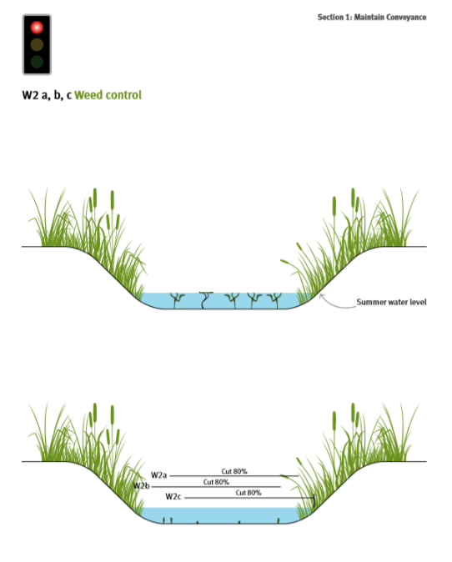

Mechanical Waterway Management:

De Weeding & Desilting

Ⓟ

Ⓟ