Ⓟ

🔒

🚑

**REACTIVE MAINTENANCE SCHEDULE**

**Task Description:** Shoal Management

**Task Code/Plan Reference:** FR19S262/001/KLJ

**Created on date:** 23/06/21 **By name**: Katy Jenkins

**CYFOETH NATURIOL CYMRU**

Plas Gwendraeth

Cross Hands Business Park

Carmarthenshire. SA14 6RE

**SYSTEM INFORMATION**

**FRM System No.:** FR19S262

**Watercourse Name:** Afon Dulais

**System Risk:** H



Reproduced by permission of Ordnance Survey on behalf of HMSO. © Crown Copyright and database right [2018]. Ordnance Survey licence number 100019741.

Atgynhyrchwyd â chaniatâd yr Arolwg Ordnans ar ran Llyfrfa ei Mawrhydi. © Hawlfraint a hawliau cronfa ddata’r Goron [2018]. Rhif Trwydded yr Arolwg Ordnans 100019741.

LEGEND

Potential compound location 🔒

Grid Ref.: SN 37221 11015

Potential loading/unloading location Ⓟ

Grid Ref.: SN 37221 11015

Potential assembly area 🚑

Grid Ref.: SN 37221 11015

**SITE PLAN:– Location:** Strady Home Farm - Pwll **NGR:** SN 48763 01223 **Postcode:** SA15 4PL

**LOCATION PLAN**

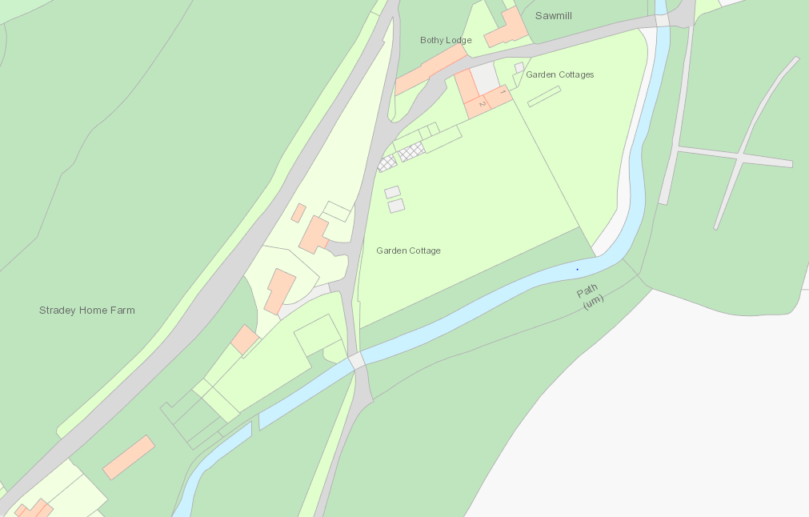

Area of Shoal (2)

Area of Shoal (1)

Shaol left near boundary hedge for landowner use

Ⓟ

🔒

Parking and Compound area to be agreed with landowner

**REACTIVE MAINTENANCE SCHEDULE**

**Task Description:** Shoal Management

**Task Code/Plan Reference:** FR19S262/002/KLJ

**Created on date:** 23/06/21 **By name**: Katy Jenkins

**CYFOETH NATURIOL CYMRU**

Plas Gwendraeth

Cross Hands Business Park

Carmarthenshire. SA14 6RE

**SYSTEM INFORMATION**

**FRM System No.:** FR19S262

**Watercourse Name:** Afon Dulais

**System Risk:** H



Works Type: Shoal Management

Asset No:

Target condition:

**COMMENTS/ADDITIONAL INFO**

**Photo 1:**

Area of shoa l 1 to be removed to maintain channel conveyance. The large shoal island is approx 23m length x 5m width and approx 0.45m depth.

**Photo 2:**

Area of shoal 2 to be removed. The smaller island is approx 5m length x 2m width an approx 0.2m depth.

Cheers

**Site Photo 1**

SITE PLAN

**Site Photo 2**

**Site Photo 3**

**Site Photo 4**

