Woodland Creation: Consultation Advice Form

CRN | A0070779
EOI | 7765347
Application Name | Esgair Arth
Parcel No.
NGR | SN489627
Option Number  (if known) | 801
Woodland category | Native Woodland - Biodiversity
Woodland Planner | Sustainable Forest Management
Service Provider | Dyfed Archaeological Trust
Officer | AMP
HEF UID | N/A
Advice  (If the proposal is considered to be inappropriate at this location please provide an explanation) | PRN122488 PWLL-GLAS POST MEDIEVAL FARMSTEAD  SN4873063190  Farmstead recorded on 2nd edition, 1:2500 Ordnance Survey map.  DAT therefore advise that in order to comply with UKFS Forests and the historic environment guidance, the following advice should be adhered to in the Woodland Creation plan:  • Planting within the area outlined in green on the map should be avoided:  • Access tracks/loading areas should not cross this area.
Further Assessment Required? | No
Map attached? | Yes
Date received | 15/09/2023 | Date replied | 09/10/2023

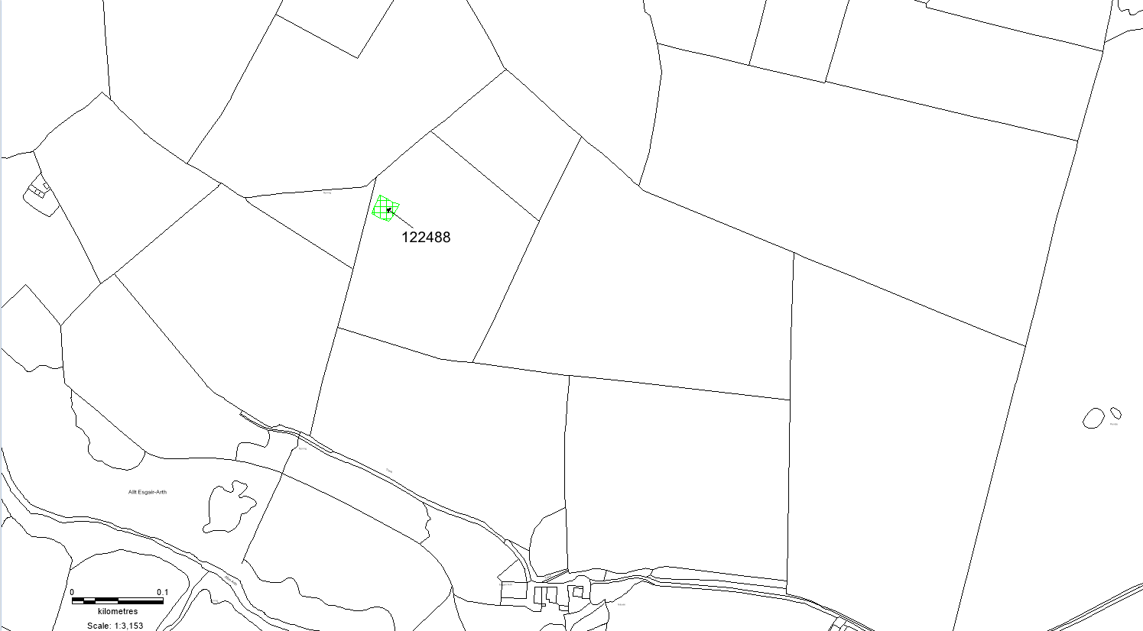
© Crown Copyright. Welsh Government. Licence Number: 100017916 (2022)
© Hawlfraint y Goron. Llywodraeth Cymru. Rhif Trwydded: 100017916 (2022)

