30th June 2023
Dear Bev,
NRW Screening Request FLA59 23-24
Ddolwen near Newcastle Emlyn.

Thank you for your felling licence consultation. I have reviewed the map boundaries against the regional Historic Environment Record (HER) and other sources and note that this application lies within the Historical Landscape Character Area of Rhos Penboyr https://dyfedarchaeology.org.uk/HLC/drefachfelindre/rhospenboyr.htm which describes this area as treeless apart from modern coniferous plantations. Historic maps show that prior to afforestation it was open common land used for grazing animals.

In addition, I have also noted the following feature recorded on the Historic Environment Record:

PRN129500 POST MEDIEVAL QUARRY SN3306734597
Old Quarry recorded on 1st Edition Ordnance Survey map. A.P 2023.
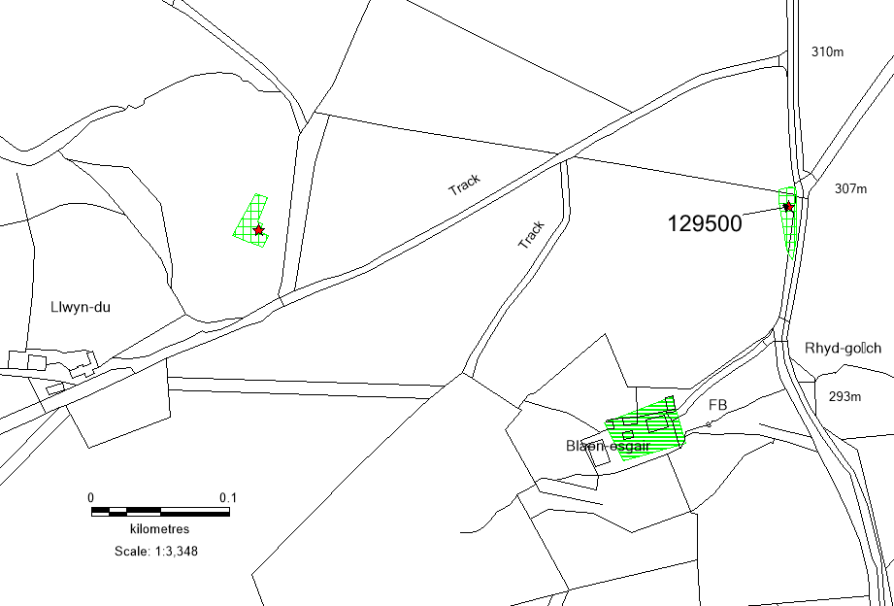

© Crown Copyright. Welsh Government. Licence Number: 100017916 (2022)
© Hawlfraint y Goron. Llywodraeth Cymru. Rhif Trwydded: 100017916 (2022)

The current condition of this feature is unknown; however, it may survive as ruins, earthworks or below ground archaeology. We advise that this historic environment feature (labelled and shown on the map above) is protected from damage during forest operations, to comply with UKFS Forests and the historic environment guidance.

There is always the possibility for previously unknown remains to survive within this area of which we have no knowledge. Should further archaeological features or finds be identified it is important that Dyfed Archaeological Trust Heritage Management is informed and further information and advice can then be provided as required.

Alexandra Powell
Heritage Management Archaeologist
a.powell@dyfedarchaeology.org.uk

