DAT 25

Dr Paul Coombes

Plant Health & Environmental Protection Branch  
Welsh Government  
Cathays Park  
Cardiff CF10 3NQ 7th June 2023

Dear Paul,

**EIA (Agriculture) Regulations - Consultation Request**

**Crymych SN 2858 3014**

Thank you for your EIA screening request, I have checked your map boundaries against the regional Historic Environment Record and other sources and note the following Historic Environment Features within this consultation area:

PRN129523 TRELECH POST MEDIEVAL FARMHOUSE SN2869730033

House and garden recorded on the parish of Treleach ar Bettws tithe map, 1844. A. Powell 2023.

PRN129524 UNKNOWN MOUND SN2838430297

Unknown mound recorded on LiDAR mapping. A. Powell 2023.

PRN129525 PLASISAF POST MEDIEVAL OUTBUILDING SN2831530290

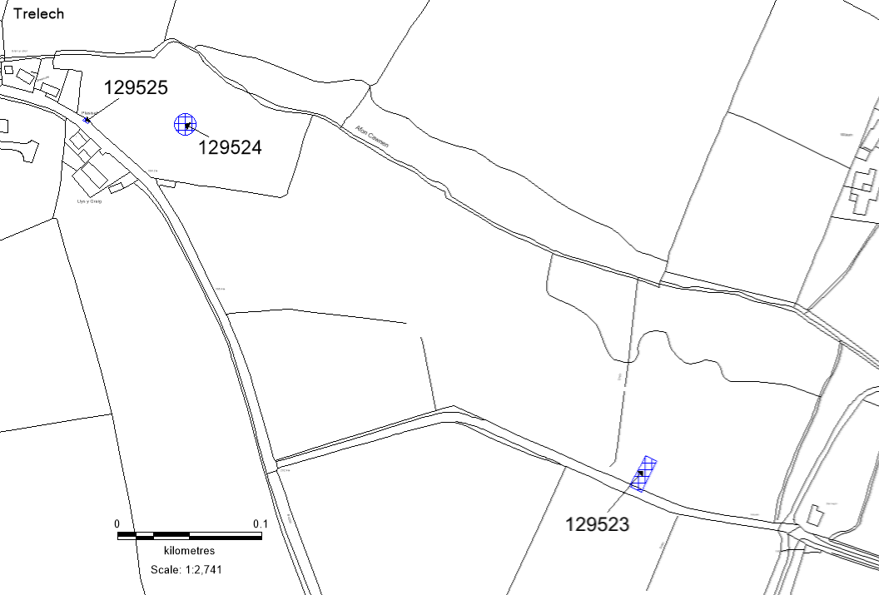Outbuilding possibly connected with the Smithy or Plasisaf farmstead (PRN111833). Recorded on 2nd Edition OS Map. A. Powell 2023.

*© Crown Copyright. Welsh Government. Licence Number: 100017916 (2022)*

*© Hawlfraint y Goron. Llywodraeth Cymru. Rhif Trwydded: 100017916 (2022).*

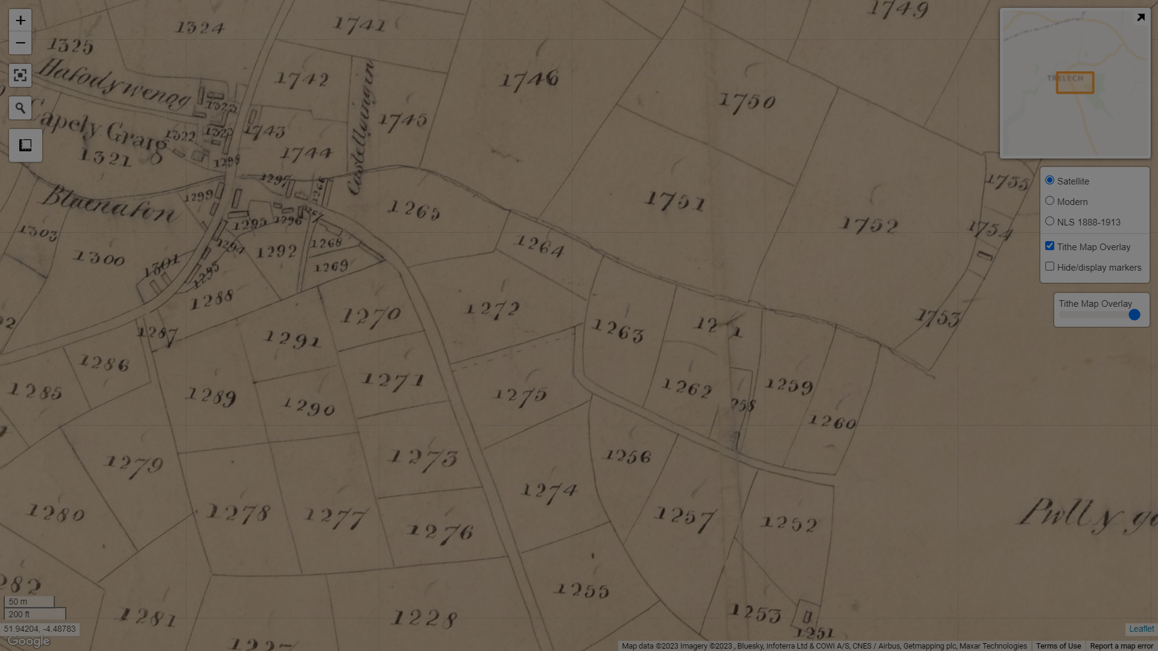*Plan of parish of Treleach ar Bettws tithe map, 1844.*

[*https://places.library.wales/browse/51.945/-4.501/17?page=1&alt=&alt=&leaflet-base-layers_66=on*](https://places.library.wales/browse/51.945/-4.501/17?page=1&alt=&alt=&leaflet-base-layers_66=on)

The consultation area encompasses parcels of land recorded on the parish of Trelech tithe map to have been owned and occupied by Morris David. A track, to the south, connects several parcels including 1258, which contains a House and Garden (PRN 129523). The removal of the field boundaries in their entirety is of concern as this represents a significant loss of a piece of the historic landscape having been recorded on the Parish tithe map of 1844, and may be earlier in date. In addition to being historic landscape features in their own right field boundaries also preserve a relic land surface beneath them, encapsulating the ground at the time which the field banks were constructed. This too is now vulnerable and may well have been damaged from the removal of the field boundaries.

Any activities must avoid causing damage to these features, shown in blue on the map above.

There is always the possibility for previously unknown remains to survive within this area of which we have no knowledge. Should further archaeological features or finds be identified it is important that Dyfed Archaeological Trust Heritage Management is informed and further information and advice can be provided as required.

If you require any more information or guidance, please get in touch.

Alexandra Powell

Heritage Management Archaeologist

a.powell@dyfedarchaeology.org.uk