16th March 2023

Dear Lynn,
NRW Screening Request FLA426 22-23 Rhos Gellie
Thank you for your felling licence consultation. I’ve had a look at the proposal in reference to the Historic Environment Record and note the following historic environment features, derived from historic map sources:

PRN 104533 POST MEDIEVAL COTTAGE SN38205359
The former cottage of Ffynnon-berw, identified on the Ordnance Survey 1st edition mapping of 1889 (O.S. Sheet 32.01). Present condition unknown.

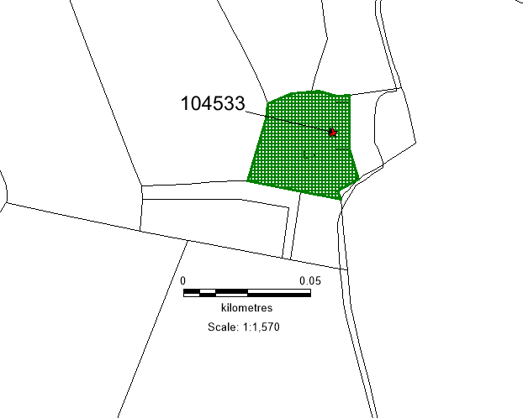

© Crown Copyright. Welsh Government. Licence Number: 100017916 (2022)
© Hawlfraint y Goron. Llywodraeth Cymru. Rhif Trwydded: 100017916 (2022)

There is always the possibility for previously unknown remains to survive within this area of which we have no knowledge. Should further archaeological features or finds be identified it is important that Dyfed Archaeological Trust Heritage Management is informed and further information and advice can then be provided as required.

Alexandra Powell
Heritage Management Archaeologist
a.powell@dyfedarchaeology.org.uk

