Permitting Officer 1 – Forestry Permitting,
Natural Resources Wales

10th May 2022
Dear Karen,

FLA 69 22-23 Talyfan, near Talog, Carmarthenshire

Thank you for your consultation. I have checked the map boundaries against the regional Historic Environment Record (HER) and other sources and note the following historic environment features recorded within the consultation area.

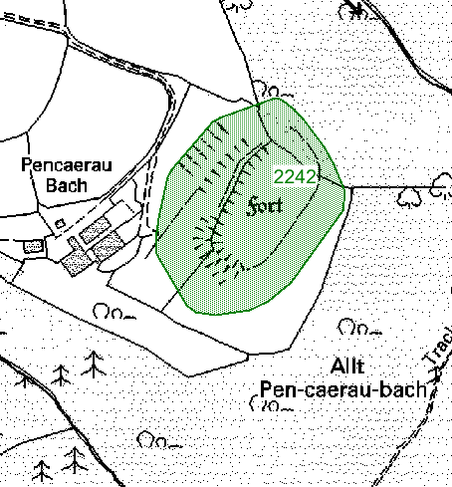

© Crown copyright and database right 2022. Ordnance Survey 100021874. Welsh Government

PRN | Summary | Type | NGR
2242 | Pencaerau-bach is a trivallate inland promontory fort occupying a rather blunt promontory at 150m above sea level. The fort is naturally protected to the north, west and southeast by steep natural slopes. It is an unusually sited fort as it is overlooked by rising ground to the west. The west and south sides are both defended by a curving bank and ditch, c. 150m long, which protects a roughly oval internal area c. 120m N-S and 60m E-W, but the west side is further protected by two additional outer defensive banks. A hedgebank runs along much of the longer inner bank. The inner bank survives to a maximum of c.1.2m and has a well-defined outer ditch. The c.60m long middle bank stands to 1m high with traces of its ditch surviving, and the c. 60m long outer bank is up to 1.7m high with a well-defined ditch. Both the middle and outer defences now terminate abruptly against a removed hedgebank - with just traces of them to the south of this removed hedgebank. The entrance through the inner bank seems to be on the south side. The site is now under improved pasture, but for most of the 20th century the site was under dense woodland.  K Murphy and R Ramsey 19 February 2008 | Promontory Fort | SN32282361

The current condition of these features is unknown; however, they may survive as ruins, earthworks or below ground archaeology. In order to comply with UKFS Forests and the historic environment guidance, DAT advise that these historic environment features (shown in green on the attached map) must be protected from damage during felling operations and that no restocking should take place within these defined areas. In addition, any ancillary operations tracks, stacking and loading areas etc must not intrude into these areas.

There is always the possibility for previously unknown remains to survive within this area of which we have no knowledge. Should further archaeological features or finds be identified it is important that Dyfed Archaeological Trust Heritage Management is informed and further information and advice can then be provided as required.

Emma Jones
Heritage Management Archaeologist
01558 825990
e.jones@dyfedarchaeology.org.uk

