Ymddiriedolaeth Archaeolegol  Dyfed  Neuadd y Sir  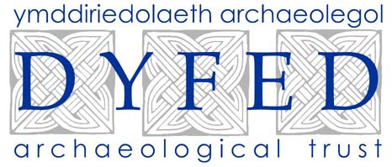  Stryd Caerfyrddin  Llandeilo  Sir Gaerfyrddin  SA19 6AF  Ffon 01558 823131  Ffacs 01558 823133  Ebost: info@dyfedarchaeology.org.uk |  | Dyfed Archaeological Trust  The Shire Hall  Carmarthen Street  Llandeilo  Carmarthenshire  SA19 6AF  Telephone 01558 823131  Fax 01558 823133  Email:info@dyfedarchaeology.org.uk

BETTER WOODLANDS FOR WALES
MANAGEMENT PLAN
HERITAGE MANAGEMENT INFORMATION
(WHE1)
05.10.10
BWW Reference No Coed Cwm Lletty 23423

Prepared by Will Steele, Dyfed Archaeological Trust
DAT Project No.
100007

INTRODUCTION AND OBJECTIVES
Coed Cwm Lletty is centred on NGR SN68439377, lying within the community of Ysgubor-y-coed in Ceredigion. Historic maps record the woodland as being long established as it is recorded on the 1st edition Ordnance Survey map of 1888. The woodlands lies on the western fringe of the rough grazing land of Tarren Neuadd-llwyd in an area characterised by dispersed farmsteads set within an undulating landscape of irregular field systems and woodlands.
Metal mining remains are much in evidence within the surrounding landscape. Historic maps (Ordnance Survey 1888, 1905) identify the shafts, levels and spoil tips of Neuadd-lwyd mine lie just outside the northeast boundary of the wood, whilst the mine reservoirs, ore bins and a crusher house lie to the east and south. A tramway linking these different areas passes through the woodland (PRN 100033). It is not known what survives of this feature today.

Historic Environment Objectives
The purpose of the management is to
- Ensure the survival of visible historic features.
- Ensure archaeological deposits beneath the ground surface are not disturbed.
- Prevent progressive degradation of historic environment features by promoting sympathetic woodland management.
- Ensure the long-term preservation of features associated with historic woodland.
- Maintain or restore the historic configuration and visual character of the historic landscape.
HISTORIC ENVIRONMENT FEATURES
A search of the regional Historic Environment Record (HER) held by the Dyfed Archaeological Trust and a field visit to the application area have identified the following historic environment features. These are listed and described below and are shown on the accompanying map. Each feature is allocated a unique reference number (a Primary Record Number - PRN) that should be quoted in any correspondence.
Each site listed must be managed in accordance with the General Management Requirements outlined below. Where sites require specific management this is set out below. These Specific Management Requirements are in addition to and (in the case of conflict) take precedence over the General Management Requirements.

PRN 100033 NAME NEUADD-LLWYD MINE STATUS None recorded
NGR SN6889093740 PERIOD Post-Medieval TYPE tramway
SUMMARY
The Ordnance Survey 1st edition map (1888) records a tramway passing through the woodland of Coed Neuadd-Llwyd linking the shafts, levels and spoil tips of Neuadd-lwyd mine with its reservoirs, ore bins and a crusher house to the south.
SPECIFIC MANAGEMENT
None

GENERAL MANAGEMENT REQUIREMENTS

All historic earthworks, structures, archaeological sites and traditional buildings must be retained and protected against damage. The above list identifies those Historic Environment Features affected by this application and the accompanying mapping shows each of these and identifies a sensitive area surrounding it. These sensitive areas must be actively managed for the life of the woodland management plan in accordance with the following requirements, in line with the Forestry Commission's Forestry & Archaeology Guidelines, 1995.

Planning
- Ensure that new planting and re-planting schemes are planned to avoid the sensitive areas surrounding historic environment features. Ideally these sensitive areas should not simply be left as unplanted islands in otherwise continuous woodland. Wherever possible these sensitive areas should be incorporated into larger buffer zones or clearings to facilitate access and ongoing management. Specific planting schemes involving historic environment features should be discussed with the Dyfed Archaeological Trust at the planning stage.
- In areas of grazed woodland, grazing regimes and stocking levels should be approved by the Dyfed Archaeological Trust prior to implementation. Similar approval should also be sought prior to significant changes to agricultural regimes.
- Consideration should be given to lessening the visual impact of new planting on historic environment features and historic landscapes.
- Consideration should be given to allowing / maintaining public access to historic environment features in woodland where this is both safe and practical. Specific access and interpretation schemes involving historic environment features should be discussed with the Dyfed Archaeological Trust at the planning stage.
- Ensure contractors and all other workers are aware of the historic environment features and comply with these requirements. They should take appropriate measures to avoid accidental damage.
Mitigation

- Do not plant or re-plant trees within the defined sensitive areas surrounding historic environment features without the prior approval of the Dyfed Archaeological Trust.
- Do not carry out any excavation or erect any new building or structure in the vicinity of historic environment features without the prior approval of the Dyfed Archaeological Trust.
- Do not site new fencing or vehicular tracks within the sensitive areas of historic environment features without the prior approval of the Dyfed Archaeological Trust.
- Do not remove any material from the sensitive areas of historic environment features or deposit spoil or rubbish on them.
- Do not store timber or machinery within the sensitive areas of historic environment features.
- Do not use heavy machinery in the sensitive areas of historic environment features, especially in wet weather.
- Do not harvest or otherwise fell trees within the sensitive areas of historic environment features without prior discussion with the Dyfed Archaeological Trust.
- No intrusive archaeological investigation (such as excavation, field-walking to collect surface finds or metal detecting) should be allowed without the prior approval of the Dyfed Archaeological Trust, to ensure that such work complies with appropriate guidance - the Institute of Field Archaeologists Code of Conduct and Standards and Guidance, and the Code of Practice for Responsible Metal Detecting in England and Wales, 2006.
Proactive management
- Control scrub and naturally regenerating trees within the sensitive areas of historic environment features. Such vegetation should be cut off at ground level with its roots being left in the ground rather than pulled up or dug out. Ensure that machinery does not cause further disturbance.
- Remove any dead or unstable trees from the vicinity of historic environment features, leaving roots to rot in situ. Ensure that machinery does not cause further disturbance.
- Where appropriate, undertake regular brashing of trees within the sensitive areas of historic environment features.
- Remove brash or other dead vegetation from the sensitive areas of historic environment features with care. Ensure that machinery does not cause further disturbance.
- Wherever practicable, repair and reuse original historic environment features, such as boundary walls, rather than replace them. Repairs should be unobtrusive and where possible make use of appropriate traditional materials and methods of construction. Schemes of repair should be discussed with the Dyfed Archaeological Trust prior to implementation.
Legislation and Guidance
- Scheduled Ancient Monuments (SAMs) have statutory protection and consent from Cadw will be required for works to these monuments.
- Listed buildings have statutory protection and permission from the Local Planning Authority will be required for some works. Listed status may also apply to buildings and structures within the curtilage of a listed building.
- Areas of historic parkland of national importance are included on the Cadw/ICOMOS Register of Parks and Gardens of Special Historic Interest in Wales. There are also many non-registered parks of lesser quality but which, nevertheless, form an important component in the historic environment and require appropriate management.
- A number of historic landscapes are registered in the Cadw/ICOMOS/CCW Registers of Outstanding and Special Landscapes of Historic Interest in Wales.
- The reporting of archaeological finds arising from woodland work must comply with the Treasure Act, 1996. Guidance on this and on the reporting of other portable antiquities can be found on the Portable Antiquities Scheme website (http://www.finds.org.uk).
- Scheduled and listed sites and registered areas are identified as such above.
Other sites may be known to the landowner and these should be made known to the Dyfed Archaeological Trust in order to update the Regional Historic Environment Record and where necessary amend management advice.

05.10.10 - HTML file produced for Better Woodlands for Wales WHE1 report, DAT project number 100007.
Dyfed Archaeological Trust, Heritage Management, The Shire Hall, 8 Carmarthen Street, Llandeilo, Carmarthenshire SA19 6AF.
tel (01558) 823131 , fax (01558) 823133, email info@dyfedarchaeology.org.uk , website www.dyfedarchaeology.org.uk

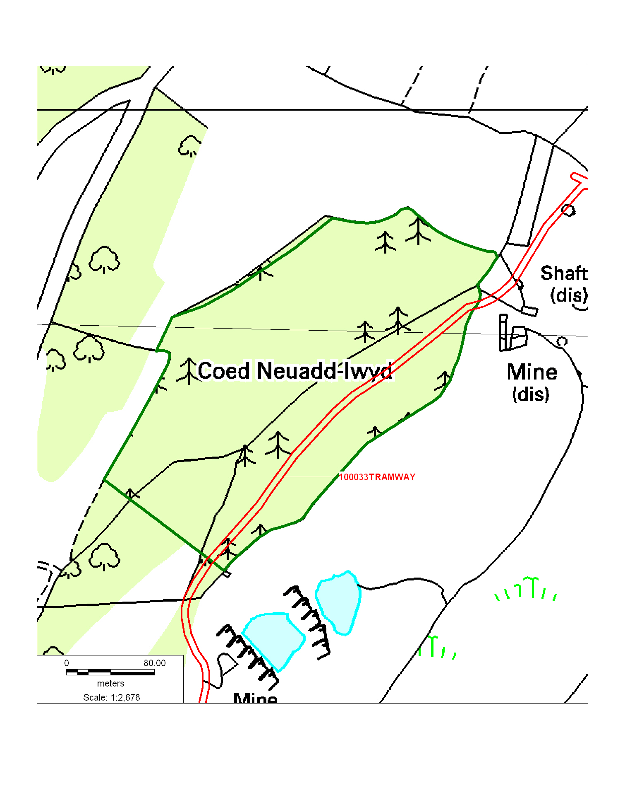
This map is based upon Ordnance Survey material with the permission of Ordnance Survey on behalf of the Controller of Her Majesty's Stationery Office Crown copyright. Unauthorised reproduction infringes Crown copyright and may lead to prosecution or civil proceedings'. Welsh Assembly Government 100017916. 10.05.10
Archaeological data, from the Regional Sites and Monuments Record, supplied by The Dyfed Archaeological Trust in partnership with Local Authorities, Cadw and the partners of ENDEX DAT, 2009 (and in part Crown, 2009).

